Channel Islands National Park Kelp Forest Monitoring Program

Kelp Forest Community Trend Report 2005-2019

Table of Contents

# Figures

Page

# Tables

Page

# Appendices

Page

# Executive Summary

Channel Islands National Park (CINP) has conducted long-term ecological monitoring of the kelp forests around San Miguel, Santa Rosa, Santa Cruz, Anacapa and Santa Barbara Islands since 1982. The original permanent transects were established at 16 sites between 1981 and 1986 with the first sampling beginning in 1982, 2019 being the 38th year of monitoring. An additional site, Miracle Mile, was established at San Miguel Island in 2001 by a commercial fisherman with assistance from the park. Miracle Mile was partially monitored from 2002-2004, and then fully monitored (using all Kelp Forest Monitoring Program (KFMP) protocols) since 2005. Only two original sites were inside a Marine Protected Area (MPA) since 1982 and it become apparent that the sample size inside and outside MPAs were too small for statistical comparisons. This type of comparison was deemed important by park management as well as other State and Federal agencies. In 2005, 16 additional permanent sites were established to collect baseline data from inside and adjacent to four State Marine Reserves (SMRs) that were established in 2003. these new sites were chosen to compliment existing sites and to best study the differences in reserve status by island. Twenty four of the 33 KFMP sites now constitute our SMR reference sites. This report thoroughly examines the effects of SMRs. Funding for the Kelp Forest Monitoring Program (KFM) has been provided by the National Park Service (NPS).

The 2005-2019 monitoring efforts utilized 808 days of vessel time to conduct 1.4761^{4} dives for a total of 1.4728^{4} hours (614 days) of bottom time at 33 monitoring sites. The number of divers average 19 per year. Population dynamics of a select list of 71 “indicator species” (consisting of taxa or categories of algae, fish, and invertebrates) were measured at the 33 permanent sites. In addition, population dynamics were measured for all additional species of fish observed at the sites during the roving diver fish count. Survey techniques follow the CINP Kelp Forest Monitoring Protocol Handbooks (Davis et al., 1997, and Kushner and Sprague, I/P). The techniques utilize SCUBA and surface-supplied-air to conduct the following monitoring protocols: 1 m² quadrats, 5 m² quadrats, band transects, random point contacts, fish transects, roving diver fish counts, video transects, size frequency measurements, and artificial recruitment modules. Hourly temperature data were collected using remote temperature loggers at 32 sites, the exception being Miracle Mile where there is no temperature logger installed. This community trend report contains a summary of survey methods used, statistical methods used for analysis, results of analysis, and a discussion of the results.

The status of kelp forests… inside trends vs outside trends… SSWD… Urchin disease

2005-2019 broad oceanographic and meteorological trends… ONI, PDO, blob, temp loggers, other

SR 2005-2019 broad trends…

SC 2005-2019 broad trends…

AN 2005-2019 broad trends…

SB 2005-2019 broad trends…

# Acknowledgments

Funding for the kelp forest monitoring program for 2005-2019 was entirely provided by the U.S. National Park Service (NPS) with most funding coming from the Stewardship of New Marine Protected Areas and some from the Inventory and Monitoring Program. The monitoring program is conducted in cooperation with the California Department of Fish and Wildlife (CDFW) and the U.S. Department of Commerce, National Oceanographic and Atmospheric Administration (NOAA), Marine Sanctuary Program.

We are deeply indebted to the many divers who have participated in this program. All volunteer divers were trained and/or certified with other agencies such as NOAA, CDFW, Aquariums and/or Universities. Without this volunteer base of well-trained and qualified divers it would be impossible to conduct this program at its current funding level. We also greatly appreciate the efforts of our boat captains and Park Dive Officers for ensuring that all our operations run safely and successfully. We would like to especially thank our incredible NPS Seasonal Kelp Forest Monitoring Biological Science Technicians.

# List of Acronyms

|  |  |
| --- | --- |
| **Acronym** | **Definition** |
| ARM | Artificial Recruitment Module |
| CDFW | California Department of Fish and Wildlife |
| CINMS | Channel Islands National Marine Sanctuary |
| CINP | Channel Islands National Park |
| CPC | Climate Prediction Center |
| ENSO | El Niño-Southern Oscillation |
| FSC | Foliar Standing Crop |
| KFMP | Kelp Forest Monitoring |
| MPA | Marine Protected Area Program |
| nMDS | Non-metric Multidimensional Scaling |
| NOAA | National Oceanic and Atmospheric Administration |
| NPS | National Park Service |
| NRPP | Natural Resources Preservation Program |
| PDO | Pacific Decadal Oscillation |
| PISCO | The Partnership for Interdisciplinary Studies of Coastal Oceans |
| ONI | Oceanic Niño Index |
| RCCA | Reef Check California |
| SBC LTER | Santa Barbara Coastal Term Ecological Research |
| SST | Sea Surface Temperature |
| SSWD | Sea Star Wasting Disease |
| SMCA | State Marine Conservation Area |
| SMR | State Marine Reserve |
| RPC | Random Point Contact |
| UCSB | University of California, Santa Barbara |

# Introduction

Kelp forests constitute one of the largest, most complex, and most threatened ecosystems in the Channel Islands National Park (CINP). Located at the boundary of two major biogeographical provinces and near unusually persistent upwelling features, the park is endowed with marine ecosystems of exceptional diversity. The five park islands are surrounded by extensive kelp forest habitat that is highly productive and relatively isolated from the mainland making them among the best examples of this important ecosystem in southern California.

The park boundary extends one nautical mile around each of the five islands, including the waters and submerged lands therein. These waters constitute less than 3% of California’s coastal zone, yet they are responsible for about 15% of the State’s coastal fishery harvests (source*). Despite defined fishing seasons, individual size and bag limits, and restricted uses in some areas, there are still no limits on total harvest of fish, lobster, algae, and other marine organisms from park waters. With the impact of harvesting and the threat of chronic and acute pollution from mainland waste disposal and adjacent offshore petroleum development, the potential for major anthropogenic disturbances exacerbated by overfishing of these ecosystems is of great concern. Natural disturbances also play an important role in the park, yet very little information on the long-term dynamics of the system is available. Providing the information required to manage these resources effectively is a challenge, but without the knowledge, there is a risk of losing these resources. Managing and conserving kelp forests requires innovative approaches and a better understanding of the long term dynamics of the ecosystem than currently exists. The KFM Program now monitors 33 sites annually, providing the longest set of fishery independent data along the west coast. A subset of 24 sites can be used to make direct comparisons of SMRs (inside vs. outside) at four of the five islands in CINP. See figure 1 for a full map of CINP and all of the KFMP sites. Please see Appendix B table XX for detailed information on site locations metadata.

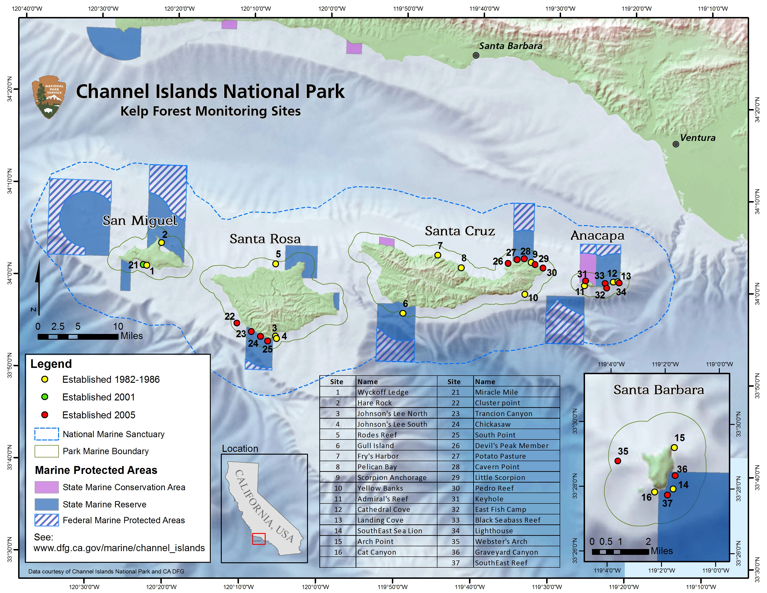 Fig 1. Channel Islands National Park Kelp Forest Monitoring Program sites.

Within each site, there are various protocols to collect abundance, size frequency distribution, percent cover, and presence/absence data on all species of fish and select indicator species for invertebrates and algae. Certain species have been labeled as “indicator species” based on the following criteria, at the discretion of the program managers:

* specifically mentioned in the park’s enabling legislation or protected by law (e.g. threatened or endangered)
* legally harvested
* exceptionally common or characteristic of entire communities
* alien to the park/invasive species
* endemic to the park, or extremely limited in distribution
* well known or “charismatic”

Species-specific characteristics, such as ease of locating and counting, relative abundance, life history, and growth rate determine what protocols are used to survey each organism. At the discretion of the lead scientist, the protocol an organism is monitored on may change or it may be counted on multiple protocols. Data consistency is of the utmost importance; often, as an organism is going to be transitioned to a different protocol, it is counted on both protocols to assure the change keeps the data consistent within a protocol. For example, following the SSWD event of 2013-2014, giant-spined sea stars were transitioned to band transects to search more habitat, though they remained a species on 1 m² quadrats. please see Appendix B, table XX for a full list of species with their associated protocols and years monitored.

Through other long term monitoring projects (Partnership for Interdisciplinary Studies of Coastal Oceans (PISCO), Santa Barbara Coastal Long Term Ecological Research (SBC LTER), Reef Check California (RCCA), etc), we have been able to confirm trends in kelp forest communities that are shown in our data/trends. One of the most drastic shifts follows SSWD that began a dramatic sea star die-off around 2013 (citation here). In a short time period, a stark decline in the number of sea stars is ubiquitous across sites regardless of MPA status. Additional trends include urchin and brittle star barrens, kelp deforestation, and abalone population declines (citations here). By consistently tracking sites through time, we can detect changes from a normal oscillation, which can often operate at the decadal scale, as well as changes from large scale environmental changes such as El Niño-Southern Oscillation (ENSO) events.

In these analyses, we compare changes in diversity, community structure, and biomass over 15 years at our 24 SMR reference sites from 2005 to 2019. While we focused on invertebrate, fish, and algal community changes through time, large scale environmental changes are also addressed when relevant. Examples include population changes linked to ENSO events and SSWD causing the extirpation of a major rocky reef predator **Pycnopodia helianthoides** (sunflower stars).

The following plot shows the Oceanic Niño Index (ONI), one of the major indicies used to track and define ENSO events and their relative strengths. Warm periods correspond to warm sea surface temperatures at the channel islands which drives many changes in species distribution. For example a warm water species may be found at a cold water island following an El Niño. 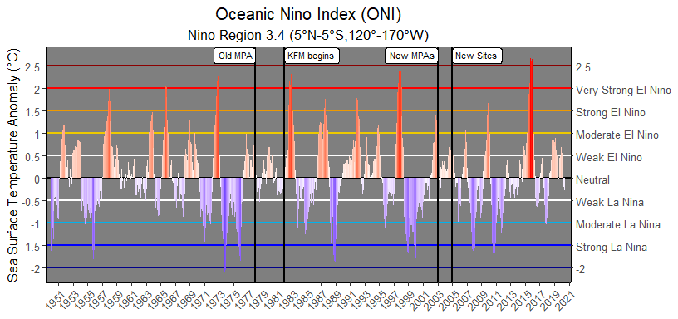

Fig 2. Oceanic Nino Index (ONI) data provided by the Climate Prediction Center at NOAA

Small explanation of HPDO index and effectsw on species… 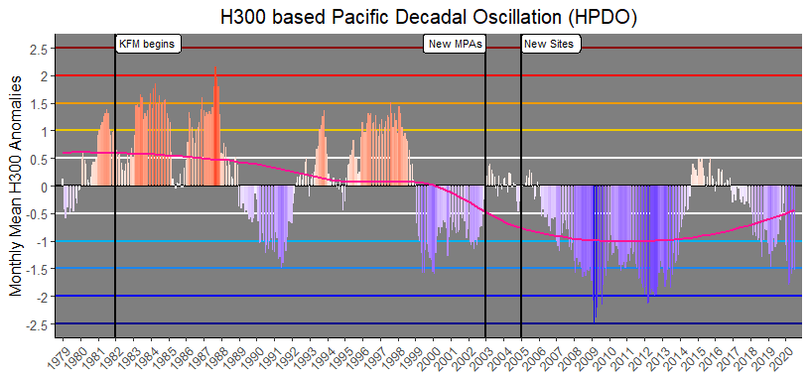

Fig 3. H300 based Pacific Decadal Oscillation (HPDO) data provided by the Climate Prediction Center at NOAA

# Methods

## Sampling Locations

The 16 sites established in 2005 were located inside or adjacent to the following four SMRs: South Point SMR at Santa Rosa Island, Scorpion SMR at Santa Cruz Island, Santa Barbara Island SMR, and the Anacapa Island SMR. Only four of the 11 newly established MPAs were selected because of limited funding and the logistical constraints of conducting this type of monitoring. The four MPAs chosen are all SMRs. These SMRs were chosen for the following reasons: accessibility, subjected to high fishing pressure prior to MPA implementation, and to make the best use of the KFM Program’s existing baseline data. New sites were established to complement existing sites so that three sites were inside, and three sites were adjacent to each of the four SMRs. Keyhole on Anacapa Island is not used for our analysis. This site was selected for monitoring because it is inside the Anacapa Island SMCA, which allows for take of pelagic finfish and California spiny lobster. This site is important for monitoring, but it was not chosen for our analysis due to the lack of replicate sites. We chose the 24 SMR reference sites to constitute the majority of our analysis. This means 12 no take sites and 12 adjacent unprotected sites.

In special cases, data from the original 16 sites is used to compare trends inside the old Anacapa island reserve established in 1978 (Source here…) to sites which became protected in 2003 (Source MLPA here…) and to sites which have never been protected. This provides a pseudo before after control impact (BACI) analysis for certain important species. It is also important to note that the old Anacapa island reserve was expanded from BLANK acres to BLANK acres in 2003 along with the implementation of the MPAs established in 2003.

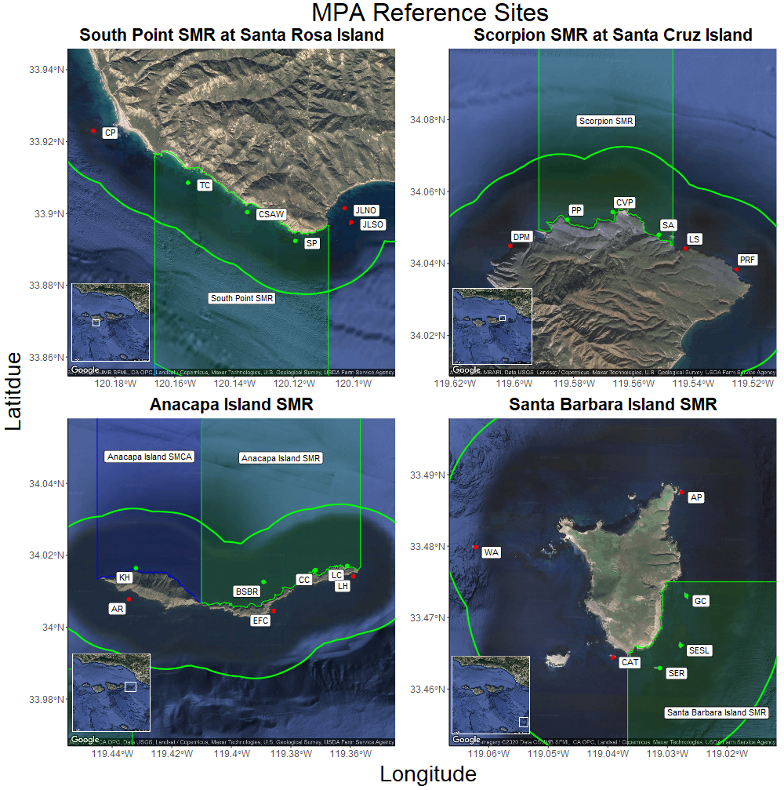

Fig 4. South Point SMR at Santa Rosa Island (top left), Scorpion SMR at Santa Cruz Island (top right), Anacapa Island SMR at Anacapa Island (bottom left), and Santa Barbara Island SMR at Santa Barbara Island (bottom right). Within-MPA sites indicated with green points, and outside-MPA sites indicated with red points. Locations of SMRs relative to the Channel Islands indicated in insets. For a complete list of KFM sites see Appendix BLANK, table BLANK.

## Survey Methods

The Kelp Forest Monitoring Program employs many different survey methods to characterize benthic and fish communities, as well as the surrounding physical environment. Each methodology is aimed at best capturing the most precise and accurate representation of the abundance of the 71 “indicator species” and all additional species of fish. Size measurements of certain invertebrates and size estimates of most species of fish give an idea of the size frequency distribution for a select list of species.

Given that all surveys are conducted on SCUBA at depths ranging from 4 m to 18 m, there are logistical considerations of data collection that must be taken into account when examining the locations, areas, times, and organisms that were sampled. Since the monitoring program’s inception, monitoring has taken place between May and October each year, with the exception of 2020 due to COVID-19. Each site has a permanent 100 m transect cable used to define the center of the 2,000 m² survey area.

There are seven survey methods which will be are use for this report: 1 m² quadrats, 5 m² quadrats, Band Transects, Roving Diver Fish Counts (RDFC), Fish Size Frequency (FSF), Random Point Contacts (RPC), and Natural Habitat Size Frequency (NHSF). The 1 m², 5 m², and Band surveys all characterize the abundance or percent cover of sedentary and mobile invertebrate species, cryptic fish, and algae. NHSF surveys, yield a size distribution for select invertebrates as well as giant kelp. These size distributions are then used to estimate biomass with a length to weight formula unique to each species (see L-W calculation table with sources). RDFC surveys and FSF surveys characterize the abundance and size frequency of fishes found in all habitats (cryptic, water column and canopy dwelling). From these data, fish biomass can be estimated with a length to weight formula unique to each species (see L-W calculation table with sources). 21 species of fish are chosen to represent the fish populations for biomass calculations. These 21 species were chosen if they met one or more of the following criteria: Prolific, Commonly targeted, Charismatic, or Herbivorous.

In 1 m² Quadrats, two divers sample a 2 m² area, at twelve equidistant, random meter numbers along the 100 m main transect line. Since each quadrat covers an area of 2 m², a total of 24 m² are covered between the two divers. Mean densities can be derived for each species on 1 m² Quadrats by dividing the count by the area surveyed. We multiply the mean density by 2,000 to get an estimated site level count. See table _____ for a list of species monitored by 1 m² Quadrats.

In 5 m² Quadrats, two divers sample forty 1 m wide by 5 m long quadrats, side by side, parallel and tangential to the 100 m main transect line. Since each quadrat covers an area of 5 m², a total of 200 m² are covered between the two divers. Mean densities can be derived for each species on 5 m² Quadrats by dividing the count by the area surveyed. We multiply the mean density by 2,000 to get an estimated site level count. See table _____ for a list of species monitored by 5 m² Quadrats.

In Band Transects, two divers sample a 60 m² area, at twelve equidistant, random meter numbers along the 100 m main transect line. Since each quadrat covers an area of 60 m², a total of 720 m² are covered between the two divers. Mean densities can be derived for each species on Band Transects by dividing the count by the area surveyed. We multiply the mean density by 2,000 to get an estimated site level count. See table _____ for a list of species monitored by Band Transects.

In RPCs, one surface supplied diver randomly samples 40 points, at fifteen equidistant, random meter numbers along the 100 m main transect line. Since each random meter has 40 points, a total of 600 points are covered by the diver. Percent cover can be derived for each species on RPCs by dividing the count by the total number of points and multiplying by 100. See table _____ for a list of species monitored by RPCs.

In RDFC, a minimum of three divers sample the entire transect footprint of 2,000 m², from the benthos to the canopy, in 30 minutes. Since each diver covers the entire site, a total of 2,000 m² are covered by each diver. Mean densities can be derived for each species on RDFC by dividing the sum of the counts by the total number of divers conducting the survey. See table _____ for a list of species monitored by RDFC.

In FSF, one diver samples within the entire transect footprint of 2,000 m², from the benthos to the canopy, with no time limit. Since the diver covers the entire site, a total of 2,000 m² is covered by the diver. Size frequency distributions for each species on FSF are estimated sizes to the nearest cm. All fish species can be entered for FSF, though typically small cryptic fish such as goby sizes are not estimated.

In NHSF, any number of divers sample randomly within transect footprint of 2,000 m², with no time limit. Since the diver samples randomly within the entire site so there is no specific area covered. Size frequency distributions for most species on NHSF are measured with vernier calipers to the nearest mm. Giant kelp stipes are counted per plant at 1 m above the benthos. Gorgonians are measured at the widest point to the nearest cm. See table _____ for a list of species monitored by NHSF

Some species are counted on multiple sampling protocols. Typically these species are added to a new protocol to better asses their density based on an evaluation of the previous methods ability to detect changes for those species as well as to select the “best” protocol to effectively search their habitat. These species continue to be counted on the previous protocol to provide consistency. For this analysis we selected the “best” survey method for each species for each year to include in our count data. The species which are also counted on RPCs were left in for the Simpson index calculation, but were not used for the random forest model.

Table XX. Protocols used for species monitored on more than one protocol.

|  |  |  |  |  |  |
| --- | --- | --- | --- | --- | --- |
| Taxa/Common Name | Scientific Name | 1 m quadrats | 5 m quadrats | band transects | RPCs |
| Oar weed | Laminaria farlowii | 1982-2019 | NA | NA | X |
| Giant kelp | Macrocystis pyrifera | 1985-1995 | 1996-2019 | NA | X |
| California sea palm | Pterygophora californica | 1982-2019 | NA | NA | X |
| Southern sea palm | Eisenia arborea | 1982-2019 | NA | NA | X |
| Devil weed | Sargassum horneri | 2010-2019 | X | X | X |
| Wakame | Undaria pinnatifida | 2016-2019 | X | X | X |
| Giant-spined sea star | Pisaster giganteus | 1982-1995 | 1996-2013 | 2014-2019 | NA |
| Ochre sea star | Pisaster ochraceus | NA | 1996-2013 | 2014-2019 | NA |

Year range indicates the protocol that was selected for the species, X indicates it is also counted on that protocol, and NA indicates that species is not monitored on that protocol. See Appendix BLANK for complete species and protocol Information

## Data Analyses and Calculations

In these analyses, we began by analyzing the trends within benthic and fish communities at KFMP MPA reference sites since 2005, using community diversity and community similarity metrics, then used a machine-learning Random Forest model, and Indicator Species Analysis to identify the variables most strongly associated with MPA protection, and which species uniquely characterized each set of communities. We then compared the species identified by each approach, and analyzed biomass or density trends over time for these important species, and also compared biomass or density ratios (inside/outside MPAs) for targeted and non-targeted benthic and fish species.

For the benthic community, we compiled data from each benthic survey type described above - 1m quadrats, 5m quadrats, and band transects, and eliminated redundant species between survey types, using only the “best” survey for each species. We then corrected for sampling areas between survey types by calculating estimated total site abundances, with $\text{density (\#/m²)}*\text{2000 m²}=\text{estimated site count}$ Roving Diver Fish Counts, however, occur over the entirety of the site, so we included these counts directly. Hereafter, this dataset of “site-level” counts for each benthic and fish species, at each site, for each year, is referred to as “community data”. Since Random Point Contact surveys (RPCs) are frequency, and not count data, we excluded substrate types (rock, sand, etc) and calculated percent cover for all species and taxonomic categories.

To test for differences in diversity between islands and MPA protection status, we calculated Shannon Index scores from our community dataset ( “Equations Used”) for each site and year combination, using the “vegan” package in R (Oksanen et al. 2019). Similarly, we calculated Simpson’s index (like Shannon Index, commonly used for percent cover data) from the RPCs data to analyze algal diversity. To test whether MPA reserve status, island, their interaction, or seawater temperature anomaly had a significant effect on community diversity over time, we used a pair of generalized linear mixed models with Shannon or Simpson Indices as the independent variables, Reserve Status, Island, Oceanic Nino Index (ONI), and the interaction of Reserve Status and Island as fixed effects, and Survey Year as a random effect, using the “lme4” package in R (Bates et al. 2015). From our community dataset, we then conducted non-metric multidimensional scaling (nMDS) to visualize the structure and grouping of site communities, and used analysis of similarity (ANOSIM) to test for significant differences in groupings between islands. To conduct these analyses, we used the “vegan” package in R (Oksanen et al. 2019).

Random Forest analysis is a machine-learning approach based on classification, or “decision” trees, which operate by repeatedly splitting data into two groups that are as homogeneous as possible, selecting the predictor which best discriminates amongst the data at each split, or “node”, and combines the results from this hierarchal process into a “tree” (Breiman 2001 a, b, James et al 2017). To measure which variables result in splits that are homogeneous as possible at each node, or minimize “impurity”, the model uses the Gini index, which reflects the proportion of responses in each level of a categorical variable - if the observations fall into few categories, the Gini index is low (James et al 2017). Because even a single classification tree will likely overfit the data, The Random Forest method uses an aggregation of many individual classification trees, created using bootstrap aggregation, or “bagging” (Breiman 1996), and the process described above, assigns a class for each observation based on which leaf it fell in, and after repeating this process 1000-5000 times, calculates the proportion of times each observation is assigned to a given class, and makes a final assignment for each observation based on the majority proportion (Breiman 2001b, James et al 2017). Since the model is derived from bootstrap aggregation (“bagging”), the set of data not selected in the bootstrap, known as the “out of bag” sample, is used to validate the tree by tallying the number of misclassifications, resulting in an out-of-bag error rate (Breiman 2001b, James et al 2017), which can be interpreted similarly to measures of model fit . Random Forest analyses return predictor variables ranked by their Gini Index (measure of impurity), as well as the decrease in accuracy, which measures how much worse the model performs without that variable included. Since Random Forests are a “black box” type of model (Breiman 2001b, James et al 2017), their process is often visualized using Partial dependence plots, which display the range of the predictor variable along the x axis (Breiman 2001a), and the line converges either at the top or bottom of the plot, depending on the level of the response variable. These curves can be interpreted to show the values at which a predictor variable becomes associated with levels of the response variable (James et al 2017). We used a random forest analysis on our fish and benthic community data, using biomass, or counts for species which did not have computed biomasses, as well as the RPC data measuring percent benthic cover. Since the analysis automatically accounts for the interactions between predictor variables based on the hierarchal nature of the classification tree (Breiman 2001a, James et al 2017), we also included Shannon and Simpson’s indices as measures of diversity, Island, and survey year. This process allowed us to determine the relative importance of each variable for accurately predicting reserve status based on the data, the corollary of which indicates the species most correlated with reserve status.

To complement our Random Forest analysis, we also used Indicator Species Analyses (ISA), a data-modelling approach, on the inside-MPA and outside-MPA data, respectively, to identify the species significantly associated with each island and MPA protection grouping, for each year. ISA assigns strength of association and significance values by comparing species occurrence to a permuted association level likely to occur by chance (De Caceres and Legendre, 2009). One of the advantages of ISA is that it accounts for both the abundance and frequency of species, is calculated separately for each species in the assemblage, and can be applied to many experimental designs, including a priori classifications like levels of a categorical variable (Bakker 2008, Dufrêne & Legendre 1997; McGeoch & Chown 1998). We then compiled the results from ISA from each year, and assembled paired heatmaps of inside- and outside-MPA data for each island, where a given species in a given year displays as red if it was not significant, or if significant displays as shades of green indicating the strength of association statistic. Thus, these heatmaps identify and visualize the trends in species importance over time associated with changes in community diversity and similarity. We conducted ISA tests using the “indicspecies” package in R (De Caceres and Legendre, 2009). Rather than the Random Forest model approach, where in order to identify the most important variables associated with Reserve Status, all data were tested as explanatory variables in a tree ensemble predicting Reserve Status, the ISA can include nested factors (which allows for assumption of an underlying stochastic data process), and returns unique series’ of indicator species for inside and outside MPA communities at each island.

The value and benefits of algorithmic modeling approaches like Random Forest are that instead of assuming that the black box has an internal stochastic data process arising from nature that generates responses from predictors, as is done in the data modeling culture (Breiman 2001b), the algorithmic modeling culture considers the black box unknown and complex, making no assumptions about the data mechanism, which allows the use of large, complex datasets while providing more accurate and informative conclusions (Breiman 2001b). However, the goal of statistics is to use data to predict information about an underlying data mechanism, and “nowhere is it written on a stone tablet what kind of model should be used to solve problems involving data” (Breiman 2001b). Thus, using both algorithmic modeling and data modeling approaches (Breiman 2001b) combined provides us better insight into which species are important in terms of MPA effects – the random forest approach allows the widest range of data to be used and provides insight into the relative strength of association with Reserve Status between many variables, while the ISA returns results for fish and benthic species specific to each combination of Island and Reserve Status, allowing for more direct insight into the changing community structures at each Reserve Status and Island, and how these trends compare to those shown in community diversity and similarity over time.

Following our community-level analyses, we calculated biomass (“Equations Used”, Appendix #) for the top several species identified as significant from Random Forest and ISA. These species corresponded closely to those identified during our literature review (e.g. kelp declines, urchin proliferation, SSWD-associated star declines, and abalone declines, spiny lobster fishery effects), as well as some “iconic” and fishery-important species (e.g. garibaldi, California sheephead, kelp bass). To test whether MPA reserve status, island, their interaction, or seawater temperature anomaly had a significant effect on these species’ biomasses over time, we used a series of generalized linear mixed models with Biomass as the independent variable, Reserve Status, Island, Oceanic Nino Index (ONI), and the interaction of Reserve Status and Island as fixed effects, and Survey Year as a random effect, using the “lme4” package in R (Bates et al. 2015). We also used bootstrapping to derive 95% confidence intervals for fish and invertebrate biomass ratios between Reserve statuses (i.e. inside biomass/outside biomass) and compared these ratios between targeted and non-targeted fishery species. The bootstrapping process randomly resamples the dataset with replacement, calculates a user-defined statistic (such as the biomass ratio), iterates through this process many times, and derives a 95% confidence interval using the derived distribution’s 2.5th and 97.5th percentiles, known as the Percentile Method (Diciccio and Romano 1988). Since bootstrapping is a non-parametric process, it is capable of estimating 95% confidence intervals without requiring data transformations, and provides a more accurate estimate of the data’s underlying distribution than lumped averages based on small sample sizes that would otherwise arise using traditional methods (n=4, one inside/outside ratio calculated per island per year). For our bootstrapping process, we calculated biomass ratios for each bootstrap subsample (equal numbers of inside and outside MPA sites were sampled in each bootstrap iteration) for 1000 iterations using the “boot” package in R (Canty and Ripley 2020), and assessed significance by comparing whether our confidence intervals contained 1 (equal biomasses inside and outside reserves). Since dividing by or with zero results in undefined values, we removed any species each year where biomass was zero for all inside or outside- MPA sites. We arranged these results by fishery-targeted and non-targeted species, as well as trophic level, which provided further insight into the effects of fishing protection on fish community structure.

While the main thrust of this report was to quantify the effects of MPAs since their implementation, understanding the changes following implementation requires also understanding the trends prior. To visualize these changes, we filtered density data for the original 16 study sites, and included all years’ data since the program began in 1982. We produced density plots with data separated by island, which is an analogous visualization to the center plots in the sets shown for the quanitative analyses post-2005, except that they also include San Miguel Island.

### Equations Used

$\text{Shannon’s Diversity Index}=−\sum_{i=1}^{s}{ }P_{i}*ln(P_{i})$

Where

* $s$ is the total number of species in the community (species richness)
* $P_{i}$ is the proportion of the total # of individuals in the community of species $i$

$\text{Biomass}=\sum_{i=1}^{n}{\frac{c}{n}}*b*d$

Where

* $c$ is the total number at a given size
* $n$ is the total number measured
* $b$ is the biomass in grams for an individual at a given size (Appendix #)
* $d$ is the density in #/ $m^{2}$ for a given site, species, and year

$\text{Foliar Standing Crop}=0.0848*\sum_{i=1}^{n}{\frac{c}{n}}*d$

Where

* $0.0848$ is the regression coefficient relating stipe density to foliar standing crop (after Rassweiler et al. 2018)
* $c$ is the total stipe count at a given size
* $n$ is the total stipe count
* $d$ is the density in #/ $m^{2}$ for a given site, species, and year

MODELS section —- See package “equatiomatic” for doing this automatically

# Results

## Community Diversity

### Benthic Invertebrate and Fish Communities - Shannon Index

Our generalized linear mixed model (GLMM) indicated significant effects on benthic and fish community diversity (Shannon Index) of MPA status (P=0), Island (P=0), their interaction (P=0.035), and the Oceanic Niño Index (ONI), a measurement of seawater temperature anomaly P=0.038; Table 2.). Significant effects of MPA status have occurred in recent years (2017-2018, Fig 5. top), whereas Santa Rosa Island had significantly higher diversity than other islands until 2013, then significantly lower diversity after 2016 (Fig 5. middle), occurring just prior to the 2015-16 El Niño event. At Santa Rosa Island, these declines in diversity were more drastic outside of MPA protection than inside (Fig 5. bottom).

Table 2. GLMM Results

Model Formula: Shannon Index = Reserve Status * Island + ONI + (1 | Survey Year)

|  |  |  |  |  |
| --- | --- | --- | --- | --- |
|  | F | Df | Df.res | Pr(>F) |
| ReserveStatus | 16.394419 | 1 | 338 | 0.0000638 |
| IslandCode | 11.835579 | 3 | 338 | 0.0000002 |
| Mean_ONI_ANOM | 5.301919 | 1 | 13 | 0.0384735 |
| ReserveStatus:IslandCode | 2.900656 | 3 | 338 | 0.0350387 |

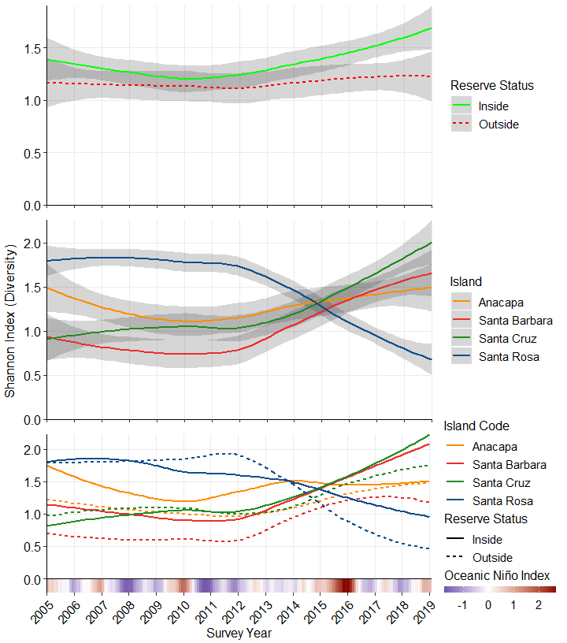 Fig 5. Community diversity by reserve status across all reference sites (Top), diversity by island across all reference sites (Middle), and diversity by island and reserve status across all reference sites (Bottom); gray intervals indicate 95% confidence ranges with LOESS smoothing. Oceanic Niño Index (ONI) is a measure of El Niño oscillation and strength, in units of *C.

### Algal and Benthic Cover Communities - Simpson’s Index

Our generalized linear mixed model indicated significant effects on algal community diversity (1-Simpson’s Index) of MPA status (P=0), Island (P=0), and their interaction (P=0.002), however ONI did not significantly affect algal community diversity in our model (P=0.071; Table 3.). Algal diversity inside MPAs became significantly higher than outside MPAs in 2013 (Fig 6. top), just prior to the 2015-16 El Niño event. Between islands, Santa Rosa previously had significantly higher algal diversity, and Santa Barbara had lower diversity, until all islands converged between 2012 and 2014 (Fig 6. middle). Lastly, algal diversity is generally lower outside an MPA than inside, at any given island (Fig 6. bottom).

Table 3. GLMM Results

Model Formula: Simpson’s Index = Reserve Status * Island + ONI + (1 | Survey Year)

|  |  |  |  |  |
| --- | --- | --- | --- | --- |
|  | F | Df | Df.res | Pr(>F) |
| ReserveStatus | 121.722325 | 1 | 338 | 0.0000000 |
| IslandCode | 20.258133 | 3 | 338 | 0.0000000 |
| Mean_ONI_ANOM | 3.863781 | 1 | 13 | 0.0710698 |
| ReserveStatus:IslandCode | 5.210900 | 3 | 338 | 0.0015741 |

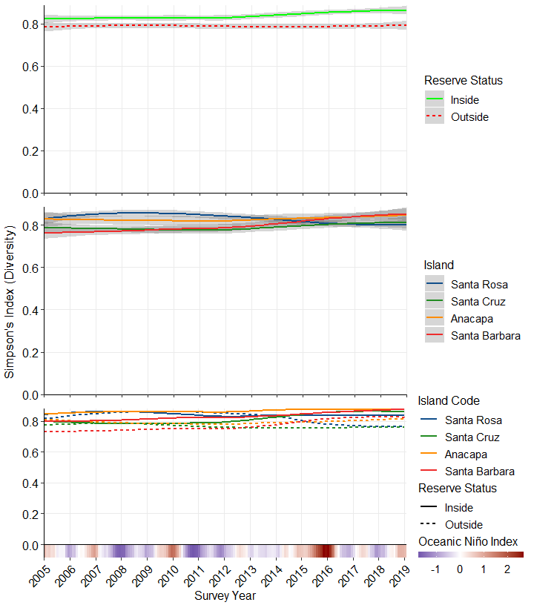 Fig 6. Simpson’s diversity by reserve status across all reference sites (Top), diversity by island across all reference sites (Middle), and diversity by island and reserve status across all reference sites (Bottom); gray intervals indicate 95% confidence ranges with LOESS smoothing. Oceanic Niño Index (ONI) is a measure of El Niño oscillation and strength, in units of *C.

## Community Similarity

Communities were significantly different at Santa Rosa Island between 2005 and 2010 (P < 0.001), before converging with the cluster comprised of Santa Cruz, Anacapa, and Santa Barbara Islands from 2012-2015, concurrent with the 2015-16 El Niño event (Fig 7.), indicated by lower R values. However, these groupings were still statistically significant (0.005 < p < 0.001 for 2010-2015, Fig 7.). Following 2015, the communities at Santa Rosa Island again become more distinctly separate, but the overlap between Santa Cruz, Anacapa, and Santa Barbara islands is higher than prior to the El Niño event (Fig 7.). Lastly, the timing of these changes in community similarity at Santa Rosa Island coincides with the changes in diversity at Santa Rosa Island (Fig 5., Fig 7.).

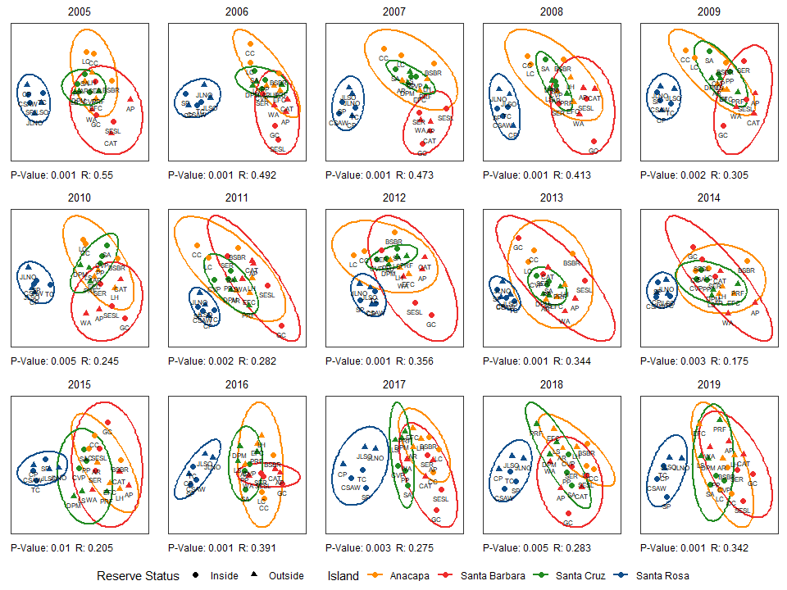 Fig 7. nMDS plots for community similarity from 2005-2019, grouped by island. Symbols represent reserve status, ellipses represent 95% confidence regions, ANOSIM R statistics and P-values are shown.

## Species Importance

### Random Forest

Random Forest analysis ranked variables by their importance to correctly classifying the data based on reserve status, based on mean decreases in accuracy (in percent), as well as the Gini index, which measures data impurity (a low Gini index indicates few misclassifications). In terms of model accuracy, the 10 most important variables included Parastichopus parvimensis (warty sea cucumber), Panulirus interruptus (California spiny lobster), Kelletia kelletii (Kellet’s whelk), Hypsypops rubicundus (Garibaldi), Simpson’s Index, Cystoseira osmundacea (chainbladder kelp), Tethya aurantia (orange puffball sponge), Strongylocentrotus franciscanus (red urchin), Stronglyocentrotus purpuratus (purple urchin), and articulated coralline algae. Partial importance plots indicate the values at which a variable consistently classified to either level of reserve status (inside or outside-MPA); the top 30 species for accuracy decrease and Gini index are shown (Fig 8.), along with their respective partial importance plots (Fig 9.).

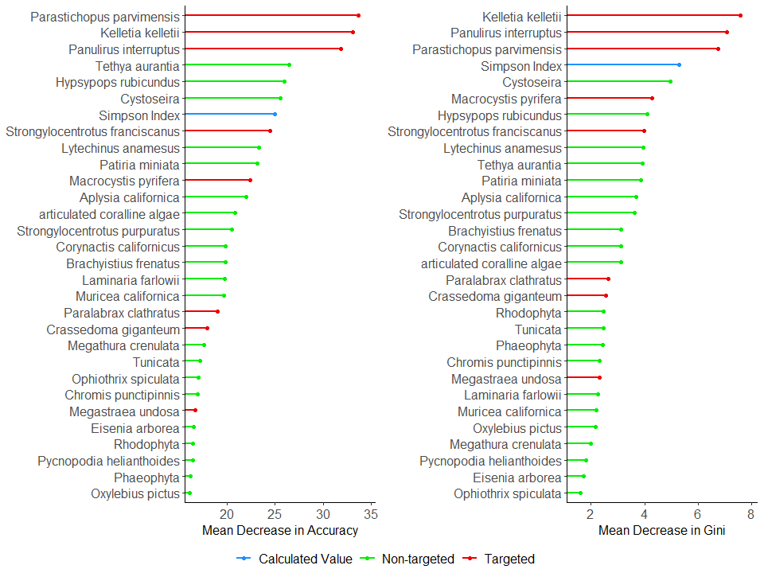 Fig 8. Variable Importance plots displaying the 30 most important variables to successfully predicting reserve status, based on mean decrease in accuracy (left) and Gini Index (a measure of data impurity where a low Gini index represents few misclassifications; right).

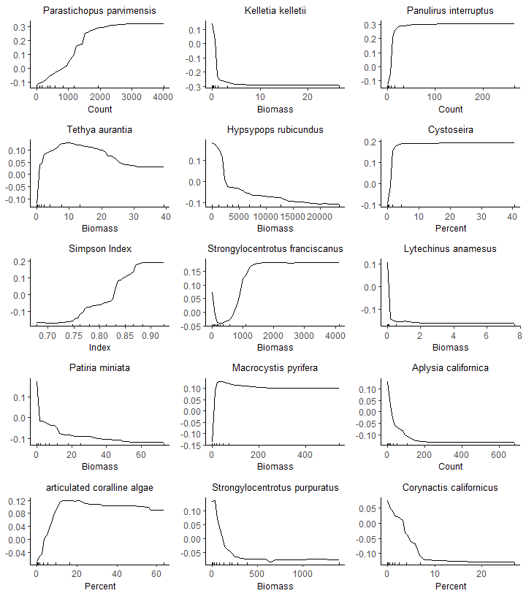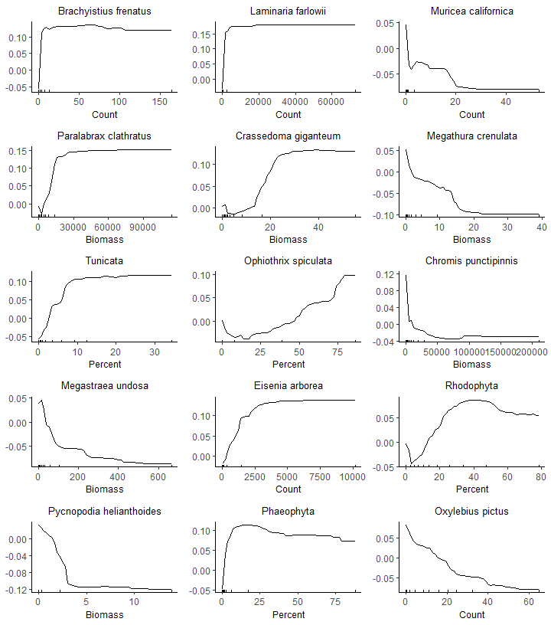 Fig 9. Partial importance plots for the top 30 species based on mean decreases in accuracy. Since the response variable is categorical, and the possible results are either “in” or “out”, lines converge either at the top or bottom of the plot and the value where convergence occurs indicates the break point across which the model classifies an observation as inside or outside-MPA.

### Indicator Species Analysis

Indicator Species analysis identified several species that were significant indicators to only inside, or outside MPA communities, as well as several which were indicators for both types of communities within an island. For the fish community at Santa Rosa Island, Embiotoca lateralis (striped surfperch), Sebastes atrovirens (kelp rockfish), S. chrysomelas (black and yellow rockfish), and S. serranoides (olive rockfish) were indicator species for both inside- and outside-MPA communities for most years, while Oxyliebus pictus (painted greenling) have been indicator species consistently since 2014/15 (Fig 10.). The Santa Rosa Island invertebrate community similarly had indicator species consistent between reserve statuses; Urticina lofotensis (white-spotted rose anemone) was a significant indicator species for all years in both communities (Fig 10.). Additional invertebrate indicator species include Tethya aurantia (orange puffball sponge), which were significant for all years except 2011-2012 outside of MPAs, but significant only in 2005, 2006, 2008, and 2018-2019 inside MPAs (Fig 10.). Pycnopodia helianthoides (sunflower star) was significant for both reserve statuses every year until 2013, while Strongylocentrotus purpuratus and Mesocentrotus franciscanus (purple and red urchins, respectively) began consistently indicating inside-MPA communities since 2015, and also outside-MPA communities in 2016-2018 (purples) and 2018 (reds; Fig 10.). Patiria miniata (bat star) were significant for every year inside MPA communities, but only in 2013, and 2015-2018 outside of MPAs (Fig 10.). Lastly, Pterygophora californica was a significant algal indicator species for outside-MPA communities for most years, until 2014 (Fig 10.).

For Santa Cruz Island, the fish community inside MPAs was indicated by Halichoeres semicinctus (rock wrasse) in 2005-2008, 2010-2011, and 2016, whereas it indicated outside-MPA communities in 2006-2007, and 2009 (Fig 11.). Hypsypops rubicundus (Garibaldi) were indicators for outside-MPA communities in 2005, 2008, and 2013, whereas they never indicated inside-MPA communities at Santa Cruz island (Fig 11.). Lythrypnus dalli (blue-banded goby) has recently (since 2016) indicated outside-MPA communities, whereas they indicated inside-MPAs only in 2016, indicating a possible recruitment event in that year. For the invertebrate community, Lophogorgia chilensis (red gorgonian) has indicated outside-MPA communities at Santa Cruz Island for all years except 2019, but has not been an indicator species in any year for inside-MPA communities (Fig 11.). Lastly, Sargassum horneri, an invasive species, indicated the outside-MPA communities at Santa Cruz in 2019 (Fig 11.).

Anacapa Island exhibited similar trends to Santa Cruz Island overall, the fish community inside-MPAs was significantly indicated by H. semicinctus in 2006-2008, 2010-2011, 2014, and 2016, whereas they also indicated outside-MPA communities in 2006-2007, and 2009 (Fig 12.). The outside-MPA community at Anacapa was indicated by Centrostephanus coronatus (coronado urchin), Muricea fruticosa (brown gorgonian), and Muricea californica (california golden gorgonian) for most years analyzed, whereas these species never indicated inside-MPA communities (Fig 12.). Similar to Santa Cruz Island, S. horneri also indicated outside-MPA communities at Anacapa for 2019 (Fig 12.).

Lastly, communities at Santa Barbara Island showed similar trends to the other warmer islands (Santa Cruz and Anacapa) for fish communities; H. rubicundus indicated outside-MPA communities in 2005, 2009, and 2013, but never indicated inside-MPA communities (Fig 13.). However, the invertebrate community inside-MPAs was significantly indicated by M. californica every year until 2018, but M. californica never indicated outside-MPA communities (Fig 13.), the opposite pattern from Anacapa Island. Tegula regina (Queen Tegula) indicated outside-MPA communities in 2006, 2008-2011, 2013-2016, but never indicated inside-MPA communities (Fig 13.).

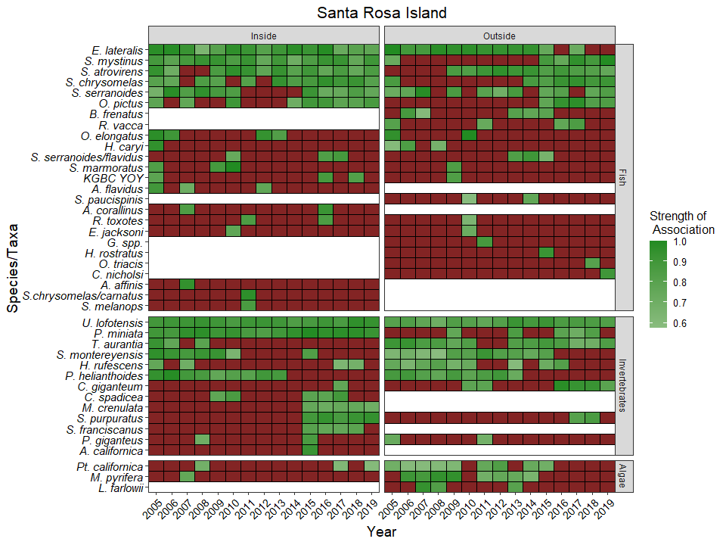 Fig 10. Indicator Species Analysis (ISA) for sites at Santa Rosa Island. ISA indicates species significantly associated with nMDS clustering groups. Values shown in heatmap indicate ISA strengths of associations scaled in green if significant, or display as red if insignificant.

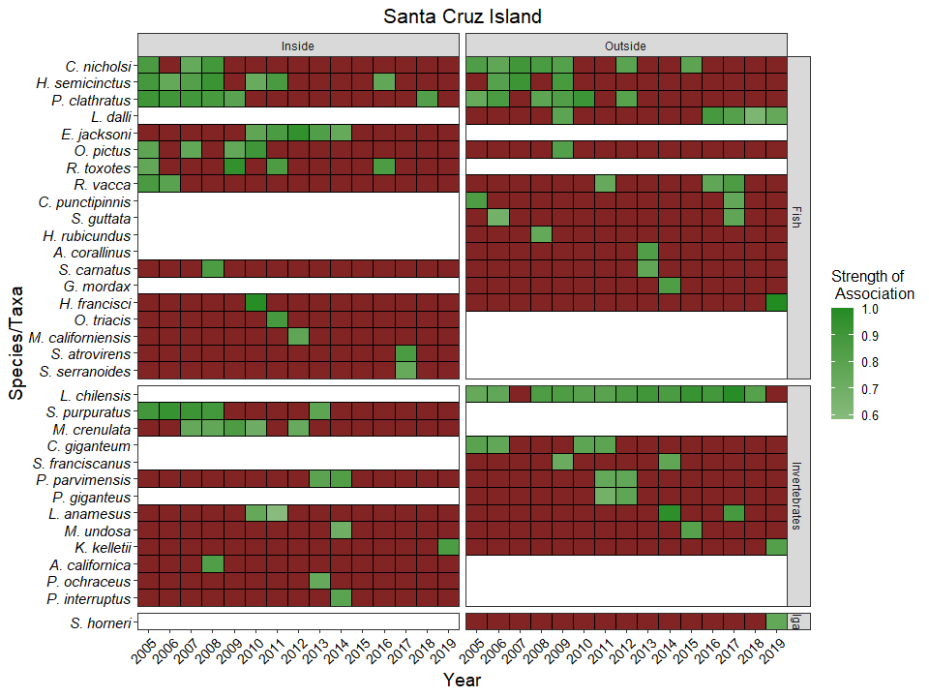 Fig 11. Indicator Species Analysis (ISA) for sites at Santa Cruz Island. ISA indicates species significantly associated with nMDS clustering groups. Values shown in heatmap indicate ISA strengths of associations scaled in green if significant, or display as red if insignificant.

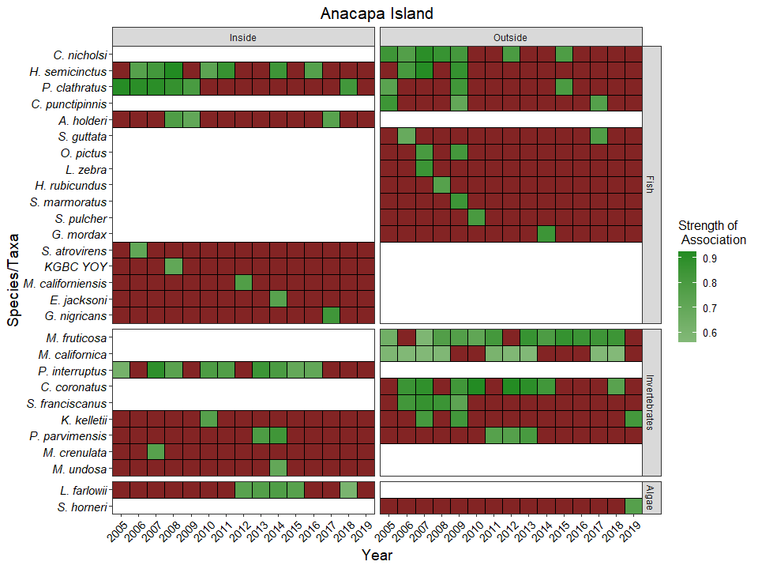 Fig 12. Indicator Species Analysis (ISA) for sites at Anacapa Island. ISA indicates species significantly associated with nMDS clustering groups. Values shown in heatmap indicate ISA strengths of associations scaled in green if significant, or display as red if insignificant.

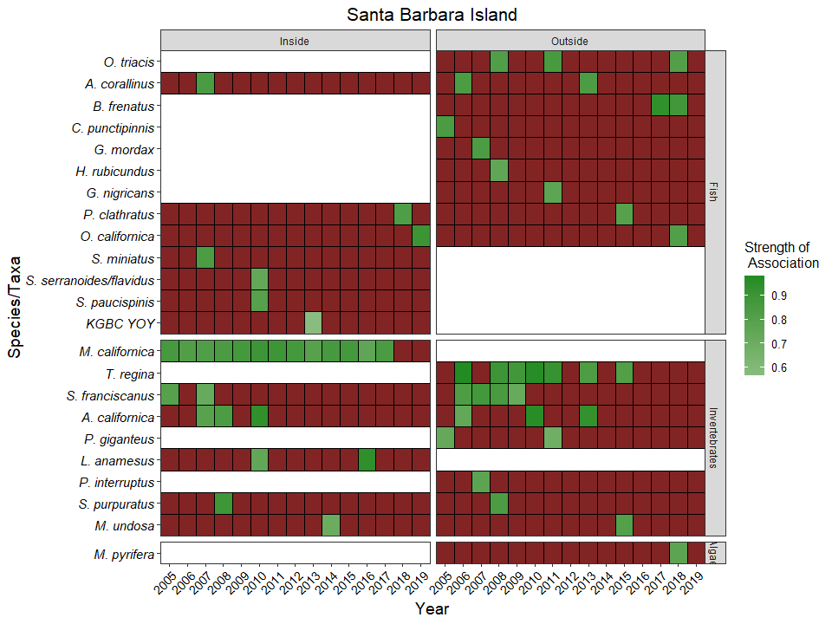 Fig 13. Indicator Species Analysis (ISA) for sites at Santa Barbara Island. ISA indicates species significantly associated with nMDS clustering groups. Values shown in heatmap indicate ISA strengths of associations scaled in green if significant, or display as red if insignificant.

Table 4. Summary cross reference table for Indicator Species Analysis.

|  |  |
| --- | --- |
| ScientificName | Years |
| Aplysia californica | 2008, 2010 |
| Artedius corallinus | 2007, 2013 |
| Chromis punctipinnis | 2005, 2017 |
| Coryphopterus nicholsi | 2005, 2006, 2007, 2008, 2009, 2012, 2015 |
| Crassedoma giganteum | 2010, 2011, 2017 |
| Embiotoca jacksoni | 2010, 2014 |
| Embiotoca lateralis | 2005, 2006, 2007, 2008, 2009, 2010, 2011, 2012, 2013, 2014, 2015, 2017 |
| Gymnothorax mordax | 2014 |
| Halichoeres semicinctus | 2006, 2007, 2008, 2009, 2010, 2011, 2016 |
| Haliotis rufescens | 2005, 2007 |
| Hypsurus caryi | 2005 |
| Hypsypops rubicundus | 2008 |
| Kelletia kelletii | 2019 |
| Laminaria farlowii | 2013 |
| Lytechinus anamesus | 2010 |
| Macrocystis pyrifera | 2007 |
| Medialuna californiensis | 2012 |
| Megastraea undosa | 2014, 2015 |
| Megathura crenulata | 2007 |
| Muricea californica | 2005, 2006, 2007, 2008, 2011, 2012, 2013, 2017 |
| Ophiodon elongatus | 2005 |
| Orthonopias triacis | 2011, 2018 |
| Oxylebius pictus | 2005, 2007, 2009, 2010, 2015, 2016, 2017, 2018, 2019 |
| Panulirus interruptus | 2007, 2014 |
| Paralabrax clathratus | 2005, 2006, 2007, 2008, 2009, 2015, 2018 |
| Parastichopus parvimensis | 2011, 2012, 2013, 2014 |
| Patiria miniata | 2009, 2013, 2016, 2017, 2018 |
| Pisaster giganteus | 2005, 2011 |
| Pterygophora californica | 2008 |
| Pycnopodia helianthoides | 2005, 2006, 2007, 2008, 2009, 2010, 2011, 2012, 2013 |
| Rhacochilus toxotes | 2011, 2016 |
| Rhacochilus vacca | 2005, 2011, 2016, 2017 |
| Sargassum horneri | 2019 |
| Scorpaena guttata | 2006, 2017 |
| Scorpaenichthys marmoratus | 2009 |
| Sebastes atrovirens | 2006, 2009, 2010, 2011, 2012, 2013, 2014, 2015, 2016, 2017, 2018, 2019 |
| Sebastes chrysomelas | 2005, 2014, 2015, 2016, 2017, 2018, 2019 |
| Sebastes mystinus | 2005, 2015, 2016, 2017, 2018, 2019 |
| Sebastes paucispinis | 2010 |
| Sebastes serranoides | 2005, 2006, 2007, 2009, 2015, 2016, 2017, 2018, 2019 |
| Sebastes serranoides/flavidus | 2010 |
| Strongylocentrotus franciscanus | 2006, 2007, 2008, 2009 |
| Strongylocentrotus purpuratus | 2008, 2017, 2018 |
| Styela montereyensis | 2005, 2006, 2007, 2008, 2009, 2010, 2015 |
| Tethya aurantia | 2005, 2006, 2008 |
| Urticina lofotensis | 2005, 2006, 2007, 2008, 2009, 2010, 2011, 2012, 2013, 2014, 2015, 2016, 2017, 2018, 2019 |

## Species-Specific Biomass, Density, and Percent Cover analyses

### Kelp Biomass

Our generalized linear mixed model indicated significant effects on Macrocystis pyrifera foliar standing crop (biomass) of MPA status (P=0), Island (P=0), and their interaction (P=0.016), but not ONI (P=0.227; Table 5.). Further, M. pyrifera biomass displayed distinct trends over time, as biomass has significantly increased inside MPA protection since 2014 (Fig 14. top), and significantly decreased at Santa Rosa Island while simultaneously increasing at Santa Cruz, Anacapa, and Santa Barbara Islands, converging during the El Niño event in 2014-2015 (Fig 14. middle), despite ONI not being significant in our model.

Table 5. GLMM Results

Model Formula: Foliar Standing Crop = Reserve Status * Island + ONI + (1 | Survey Year)

|  |  |  |  |  |
| --- | --- | --- | --- | --- |
|  | F | Df | Df.res | Pr(>F) |
| ReserveStatus | 41.644261 | 1 | 338 | 0.0000000 |
| IslandCode | 8.272410 | 3 | 338 | 0.0000252 |
| Mean_ONI_ANOM | 1.610851 | 1 | 13 | 0.2266250 |
| ReserveStatus:IslandCode | 3.476536 | 3 | 338 | 0.0162771 |

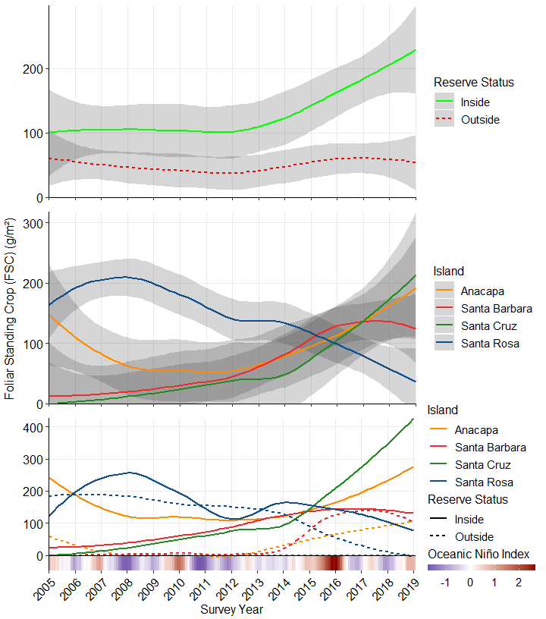 Fig 14. Macrocystis pyrifera foliar standing crop (FSC) by reserve status across all reference sites (Top), FSC by island across all reference sites (Middle), and FSC by island and reserve status across all reference sites (Bottom); gray intervals indicate 95% confidence ranges with LOESS smoothing. Oceanic Niño Index (ONI) is a measure of El Niño oscillation and strength, in units of *C.

### Purple Urchin Biomass

Our generalized linear mixed model indicated significant effects on Strongylocentrotus purpuratus biomass of of MPA status (P=0), Island (P=0), and their interaction (P=0), but not ONI (P=0.997; Table 6.). S. purpuratus biomass also displayed distinct trends over time, opposite to those we observed for M. pyrifera: S. purpuratus as biomass has significantly decreased inside MPA protection since 2013, but remained relatively consistent outside MPAs (Fig 15. top), and significantly increased at Santa Rosa Island while simultaneously decreasing at Santa Cruz, Anacapa, and Santa Barbara Islands, converging just prior to El Niño event in 2014-2015 (Fig 15. middle), despite ONI not being significant in our model.

Table 6. GLMM Results

Model Formula: Purple Urchin Biomass = Reserve Status * Island + ONI + (1 | Survey Year)

|  |  |  |  |  |
| --- | --- | --- | --- | --- |
|  | F | Df | Df.res | Pr(>F) |
| ReserveStatus | 23.8772391 | 1 | 338 | 0.0000016 |
| IslandCode | 8.0926379 | 3 | 338 | 0.0000321 |
| Mean_ONI_ANOM | 0.0000149 | 1 | 13 | 0.9969764 |
| ReserveStatus:IslandCode | 7.2987572 | 3 | 338 | 0.0000935 |

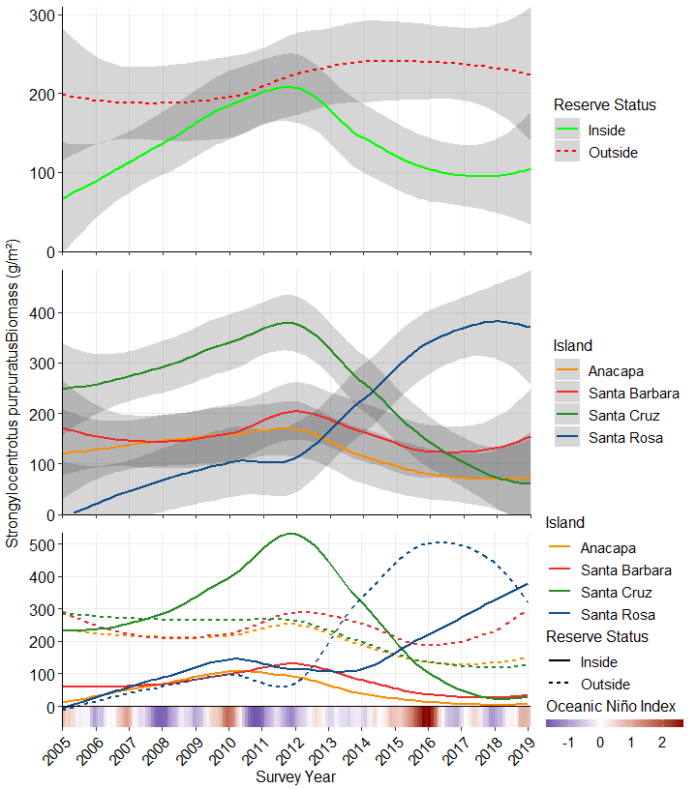 Fig 15. Strongylocentrotus purpuratus (purple urchin) biomass by reserve status across all reference sites (Top), by island across all reference sites (Middle), and by island and reserve status across all reference sites (Bottom); gray intervals indicate 95% confidence ranges with LOESS smoothing. Oceanic Niño Index (ONI) is a measure of El Niño oscillation and strength, in units of *C.

### Red Urchin Biomass

Our generalized linear mixed model indicated significant effects on Mesocentrotus franciscanus biomass of of MPA status (P=0), Island (P=0), and their interaction (P=0), but not ONI (P=0.997; Table 7.). However, the trends over time for MPA protection status and Island were opposite from those observed for S. purpuratus. M. franciscanus biomass has significantly decreased inside MPA protection since 2013, but less so outside MPAs (Fig 16. top), and significantly increased at Santa Rosa Island before declining recently, while simultaneously decreasing at Santa Cruz, Anacapa, and Santa Barbara Islands (Fig 16. middle). While ONI was not significant in our model, the onset of biomass decline at Santa Rosa Island was concurrent with the 2013-15 El Niño event.

Table 7.. GLMM Results

Model Formula: Red Urchin Biomass = Reserve Status * Island + ONI + (1 | Survey Year)

|  |  |  |  |  |
| --- | --- | --- | --- | --- |
|  | F | Df | Df.res | Pr(>F) |
| ReserveStatus | 29.2080006 | 1 | 338 | 0.0000001 |
| IslandCode | 22.8766881 | 3 | 338 | 0.0000000 |
| Mean_ONI_ANOM | 0.0000176 | 1 | 13 | 0.9967124 |
| ReserveStatus:IslandCode | 11.5736092 | 3 | 338 | 0.0000003 |

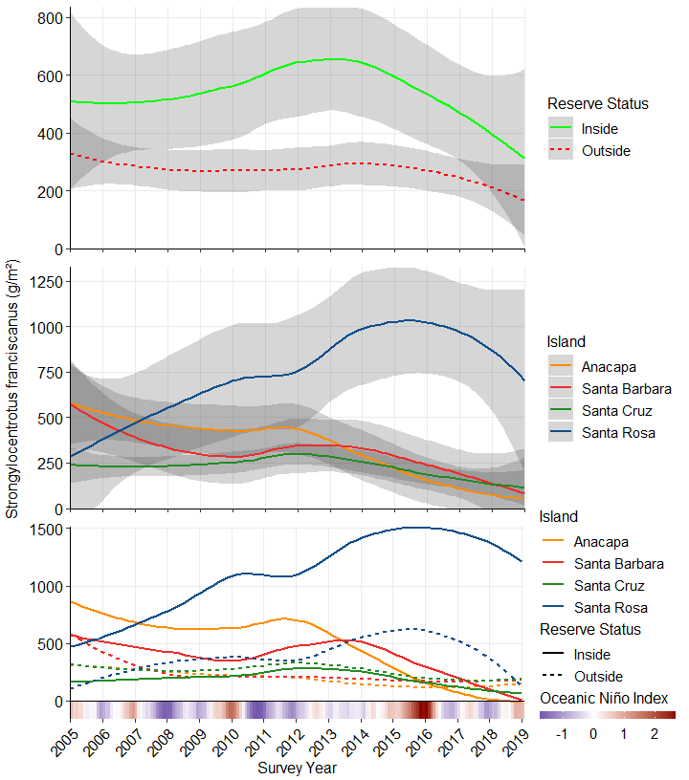 Fig 16. Strongylocentrotus franciscanus (red urchin) biomass by reserve status across all reference sites (Top), biomass by island across all reference sites (Middle), and FSC by island and reserve status acrossall reference sites (Bottom); gray intervals indicate 95% confidence ranges with LOESS smoothing. Oceanic Niño Index (ONI) is a measure of El Niño oscillation and strength, in units of *C.

### Pycnopodia helianthoides Biomass

Our generalized linear mixed model indicated significant effects on Pycnopodia helianthoides biomass of MPA status (P=0), Island (P=0), their interaction (P=0.004), and ONI (P=0.049; Table 8.). P. helianthoides biomass has completely collapsed since 2013, concurrent with the onset of the 2015-16 El Niño event, but prior to 2013 biomass was significantly higher outside MPAs (Fig 17. top), but also declined more significantly outside MPAs than inside MPAs. Prior to 2013, P helianthoides biomass was also significantly higher at Santa Rosa Island (Fig 17. middle). Lastly, this pattern is opposite of that observed for S. purpuratus.

Table 8. GLMM Results

Model Formula: Sunflower star Biomass = Reserve Status * Island + ONI + (1 | Survey Year)

|  |  |  |  |  |
| --- | --- | --- | --- | --- |
|  | F | Df | Df.res | Pr(>F) |
| ReserveStatus | 13.014179 | 1 | 338 | 0.0003558 |
| IslandCode | 39.994096 | 3 | 338 | 0.0000000 |
| Mean_ONI_ANOM | 4.721876 | 1 | 13 | 0.0488588 |
| ReserveStatus:IslandCode | 4.465182 | 3 | 338 | 0.0043106 |

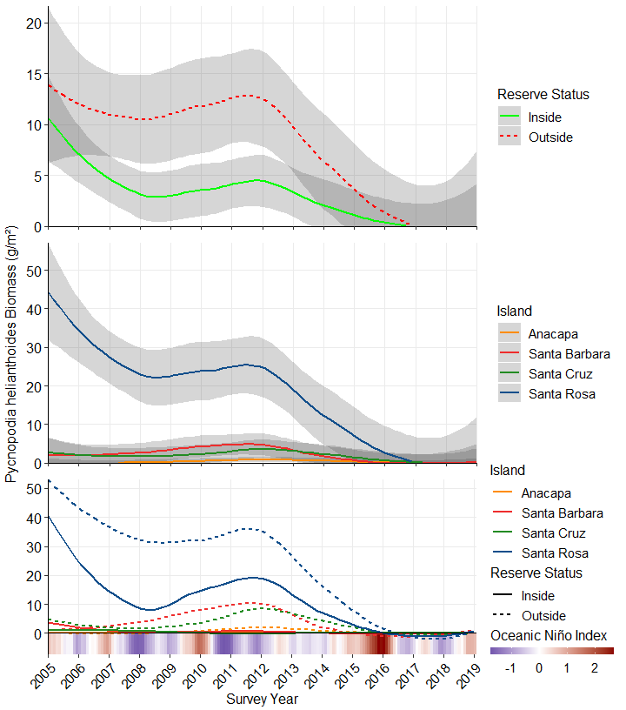 Fig 17. Pycnopodia helianthoides (sunflower star) biomass by reserve status across all reference sites (Top), biomass by island across all reference sites (Middle), and biomass by island and reserve status across all reference sites (Bottom); gray intervals indicate 95% confidence ranges with LOESS smoothing. Oceanic Niño Index (ONI) is a measure of El Niño oscillation and strength, in units of *C.

## Pisaster giganteus Biomass

Our generalized linear mixed model indicated significant effects of MPA status (P=0.015), Island (P=0), their interaction (P=0.002), and ONI (P=0.012; Table 9.). Similar to other sea star species, Pisaster giganteus populations, which were previously largest outside MPAs (Fig 18. top) and at Santa Cruz Island (Fig 18. middle), crashed to minimal or absent populations during the 2013-2015 El Niño event.

Table 9. GLMM Results

Model Formula: Red Urchin Biomass = Reserve Status * Island + ONI + (1 | Survey Year)

|  |  |  |  |  |
| --- | --- | --- | --- | --- |
|  | F | Df | Df.res | Pr(>F) |
| ReserveStatus | 5.950116 | 1 | 338 | 0.0152302 |
| IslandCode | 22.019859 | 3 | 338 | 0.0000000 |
| Mean_ONI_ANOM | 8.564925 | 1 | 13 | 0.0117904 |
| ReserveStatus:IslandCode | 5.080098 | 3 | 338 | 0.0018787 |

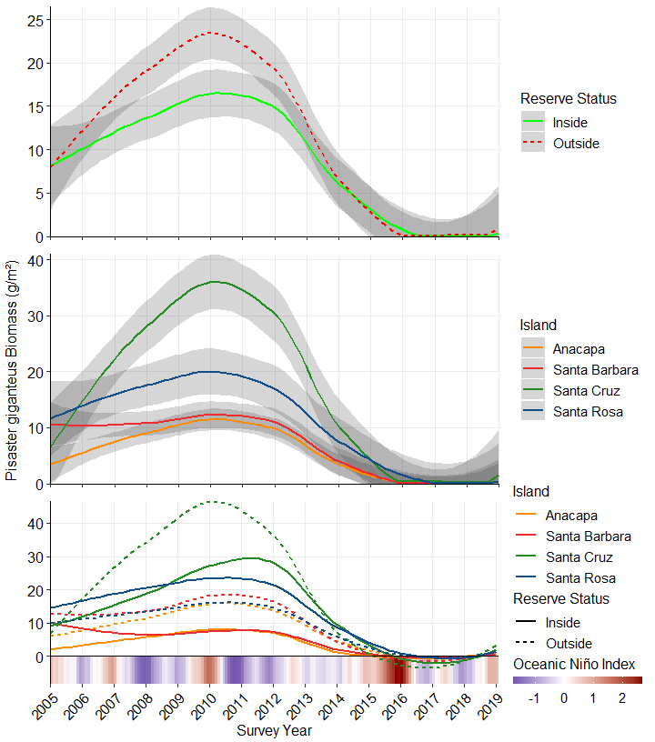 Fig 18. Pisaster giganteus (giant-spined star) biomass by reserve status across all reference sites (Top), biomass by island across all reference sites (Middle), and biomass by island and reserve status across all reference sites (Bottom); gray intervals indicate 95% confidence ranges with LOESS smoothing. Oceanic Niño Index (ONI) is a measure of El Niño oscillation and strength, in units of *C.

### Patiria miniata Biomass

Our generalized linear mixed model indicated significant effects of MPA status (P=0), Island (P=0), their interaction (P=0.102), and ONI (P=0.031; Table 10.). Patiria miniata populations were highest outside of MPAs (Fig 19. top), and at Santa Rosa Island (Fig 19. middle). However, unlike other sea star species, Patiria miniata populations declined to absence only at warmer water islands (Santa Cruz, Anacapa, Santa Barbara), and this occurred following, rather than concurrently with, the 2013-15 El Niño event, and populations declined but stayed present throughout at Santa Rosa Island regardless of reserve status (Fig 19. bottom).

Table 10. GLMM Results

Model Formula: Bat star Biomass = Reserve Status * Island + ONI + (1 | Survey Year)

|  |  |  |  |  |
| --- | --- | --- | --- | --- |
|  | F | Df | Df.res | Pr(>F) |
| ReserveStatus | 33.910390 | 1 | 338 | 0.0000000 |
| IslandCode | 88.882637 | 3 | 338 | 0.0000000 |
| Mean_ONI_ANOM | 5.871317 | 1 | 13 | 0.0307272 |
| ReserveStatus:IslandCode | 2.087858 | 3 | 338 | 0.1015881 |

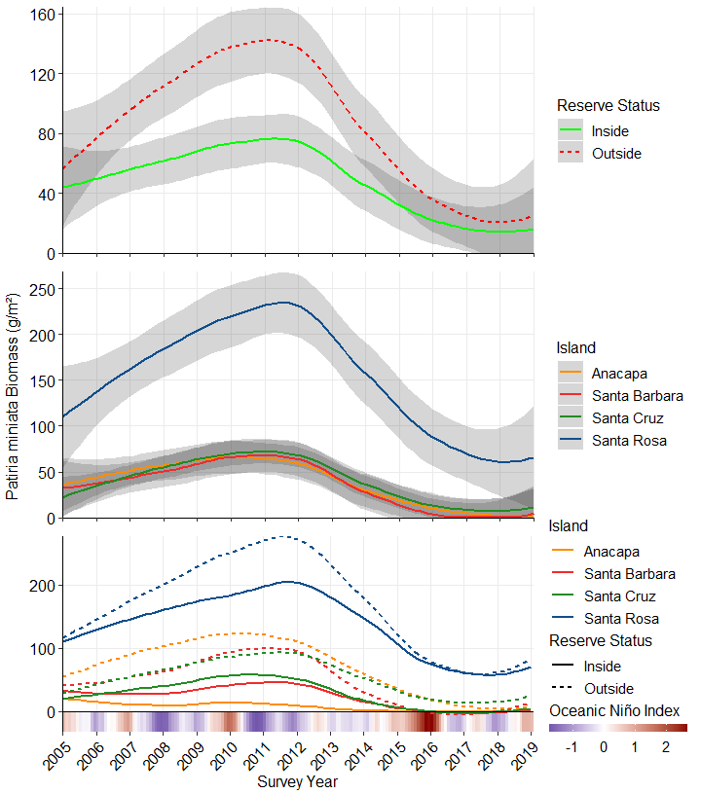 Fig 19.. Patiria miniata (bat star) biomass by reserve status across all reference sites (Top), biomass by island across all reference sites (Middle), and biomass by island and reserve status across all reference sites (Bottom); gray intervals indicate 95% confidence ranges with LOESS smoothing. Oceanic Niño Index (ONI) is a measure of El Niño oscillation and strength, in units of *C.

### Haliotis rufescens Biomass

Our generalized linear mixed model indicated significant effects of MPA status (P=0), Island (P=0), and their interaction (P=0), but not ONI (Table 11.). In the MPA reference dataset, Haliotis rufescens only occurred at Santa Rosa Island (however, they are also present at San Miguel Island), and populations were larger inside MPAs (Fig 20. bottom). Concurrent with the 2013-15 El Niño event, Haliotis rufescens populations have declined, and a population is maintained inside MPAs at Santa Rosa Island.

Table 11. GLMM Results

Model Formula: Red abalone Biomass = Reserve Status * Island + ONI + (1 | Survey Year)

|  |  |  |  |  |
| --- | --- | --- | --- | --- |
|  | F | Df | Df.res | Pr(>F) |
| ReserveStatus | 21.687256 | 1 | 338 | 0.0000046 |
| IslandCode | 51.192264 | 3 | 338 | 0.0000000 |
| Mean_ONI_ANOM | 1.750436 | 1 | 13 | 0.2086222 |
| ReserveStatus:IslandCode | 21.690055 | 3 | 338 | 0.0000000 |

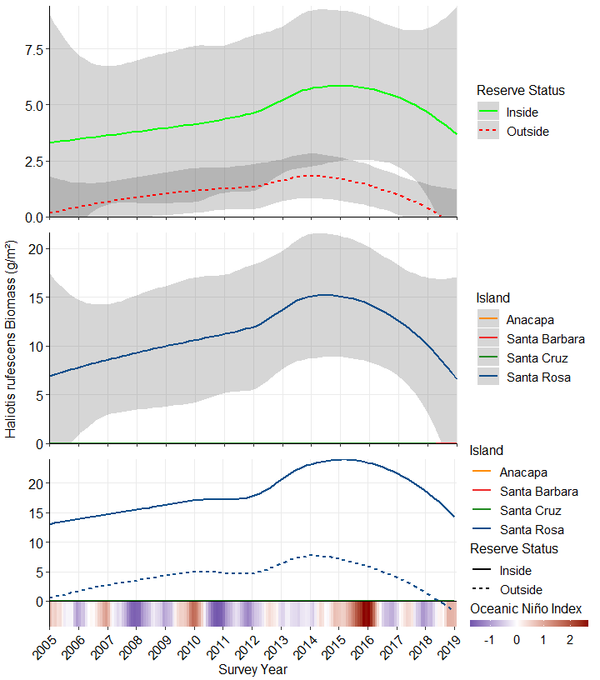 Fig 20. Haliotis rufescens (red abalone) biomass by reserve status across all reference sites (A), biomass by island across all reference sites (B), and FSC by island and reserve status across all reference sites (C); gray intervals indicate 95% confidence ranges with LOESS smoothing. Oceanic Niño Index (ONI) is a measure of El Niño oscillation and strength, in units of *C.

### Tethya aurantia Biomass

Our generalized linear mixed model indicated significant effects of Island (P=0), the interaction between Island and MPA status (P=0), and ONI (P=0.033), but not MPA status alone (P=0.76; Table 12.). Populations were substantially larger at Santa Rosa Island prior to 2013 (Fig 21. middle), but then decline at all islands during and following the 2013-15 El Niño Event.

Table 12. GLMM Results

Model Formula: Orange Puffball sponge Biomass = Reserve Status * Island + ONI + (1 | Survey Year)

|  |  |  |  |  |
| --- | --- | --- | --- | --- |
|  | F | Df | Df.res | Pr(>F) |
| ReserveStatus | 0.0932196 | 1 | 338 | 0.7603113 |
| IslandCode | 185.2873158 | 3 | 338 | 0.0000000 |
| Mean_ONI_ANOM | 5.6808667 | 1 | 13 | 0.0330934 |
| ReserveStatus:IslandCode | 6.3348506 | 3 | 338 | 0.0003441 |

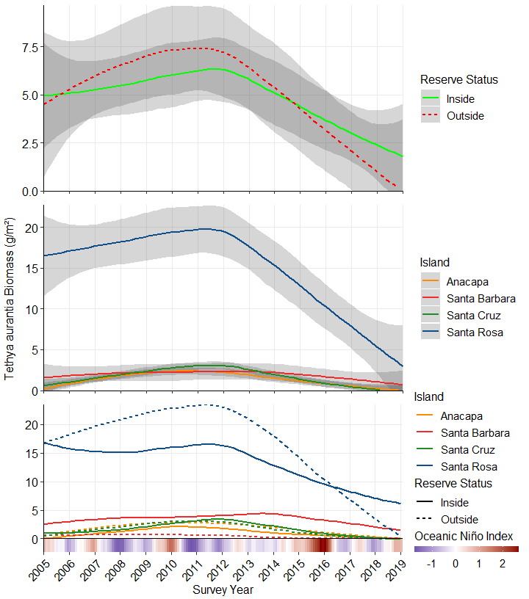 Fig 21. Tethya aurantia (orange puffball sponge) biomass by reserve status across all reference sites (A), biomass by island across all reference sites (B), and FSC by island and reserve status across all reference sites (C); gray intervals indicate 95% confidence ranges with LOESS smoothing. Oceanic Niño Index (ONI) is a measure of El Niño oscillation and strength, in units of *C.

### Kellet’s whelk Biomass

Our generalized linear mixed model indicated significant effects of MPA status (P=0), Island (P=0), and their interaction (P=0), but not ONI (Table 13.). Populations were substantially larger at Santa Rosa Island prior to 2013 (Fig 22. middle), but then decline at all islands during and following the 2013-15 El Niño Event.

Table 13. GLMM Results

Model Formula: Kellet’s whelk Biomass = Reserve Status * Island + ONI + (1 | Survey Year)

|  |  |  |  |  |
| --- | --- | --- | --- | --- |
|  | F | Df | Df.res | Pr(>F) |
| ReserveStatus | 51.488094 | 1 | 338 | 0.0000000 |
| IslandCode | 13.590412 | 3 | 338 | 0.0000000 |
| Mean_ONI_ANOM | 3.612730 | 1 | 13 | 0.0797403 |
| ReserveStatus:IslandCode | 8.731593 | 3 | 338 | 0.0000136 |

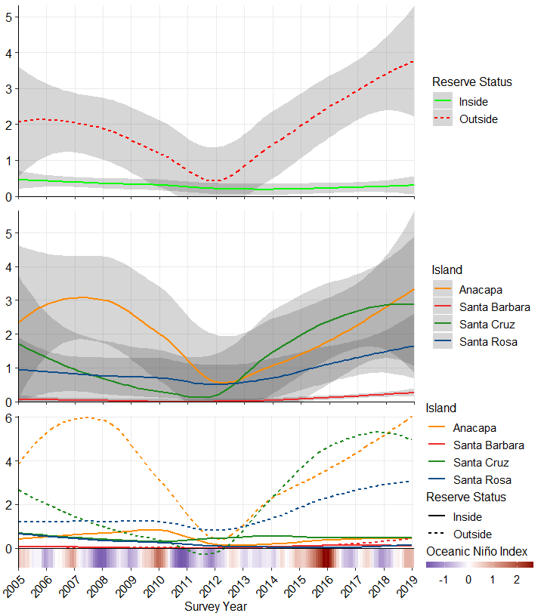 Fig 22. Kelletia kelletii (Kellet’s whelk) biomass by reserve status across all reference sites (A), biomass by island across all reference sites (B), and FSC by island and reserve status across all reference sites (C); gray intervals indicate 95% confidence ranges with LOESS smoothing. Oceanic Niño Index (ONI) is a measure of El Niño oscillation and strength, in units of *C.

## Hypsypops rubicundis Biomass

Our generalized linear mixed model indicated significant effects of MPA status (P=0), Island (P=0), but not their interaction or ONI (Table 14.). Beginning in 2012, Hypsypops rubicundus have significantly more biomass outside of MPA protection than inside (Fig 23. top), and while populations are stable at Santa Cruz and Santa Barbara Islands, the population at Anacapa Island has grown since 2013 (Fig 23. middle).

Table 14. GLMM Results

Model Formula: Orange Puffball sponge Biomass = Reserve Status * Island + ONI + (1 | Survey Year)

|  |  |  |  |  |
| --- | --- | --- | --- | --- |
|  | F | Df | Df.res | Pr(>F) |
| ReserveStatus | 40.433247 | 1 | 338 | 0.0000000 |
| IslandCode | 57.457748 | 3 | 338 | 0.0000000 |
| Mean_ONI_ANOM | 4.408171 | 1 | 13 | 0.0558567 |
| ReserveStatus:IslandCode | 2.386435 | 3 | 338 | 0.0689311 |

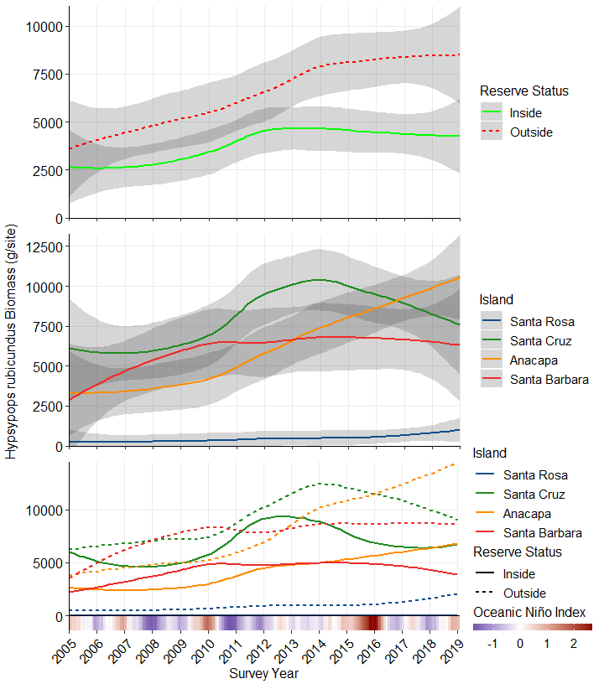 Fig 23. Hypsypops rubicundus (Garibaldi) biomass by reserve status across all reference sites (Top), biomass by island across all reference sites (Middle), and FSC by island and reserve status across all reference sites (Bottom); gray intervals indicate 95% confidence ranges with LOESS smoothing. Oceanic Niño Index (ONI) is a measure of El Niño oscillation and strength, in units of *C.

### Halichoeres semicinctus Biomass

Our generalized linear mixed model indicated significant effects of Island (P=0), but not MPA status, the interaction, or ONI (Table 15.). Halichoeres semicinctus populations had relatively low biomasses until 2013, when the populations grew drastically at Santa Barbara, Anacapa, and Santa Cruz Islands (Fig 24. middle).

Table 15. GLMM Results

Model Formula: Orange Puffball sponge Biomass = Reserve Status * Island + ONI + (1 | Survey Year)

|  |  |  |  |  |
| --- | --- | --- | --- | --- |
|  | F | Df | Df.res | Pr(>F) |
| ReserveStatus | 0.2968646 | 1 | 338 | 0.5862141 |
| IslandCode | 18.5365887 | 3 | 338 | 0.0000000 |
| Mean_ONI_ANOM | 2.8702612 | 1 | 13 | 0.1140373 |
| ReserveStatus:IslandCode | 0.5110885 | 3 | 338 | 0.6748915 |

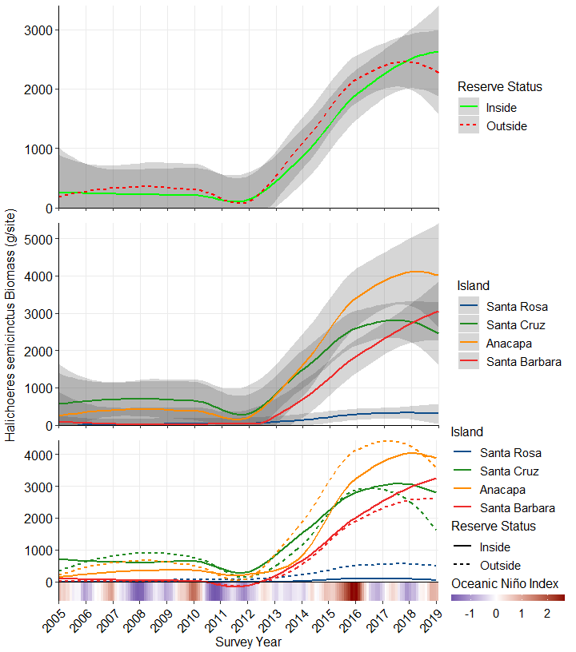 Fig 24. Halichoeres semicinctus (Rock Wrasse) biomass by reserve status across all reference sites (Top), biomass by island across all reference sites (Middle), and FSC by island and reserve status across all reference sites (Bottom); gray intervals indicate 95% confidence ranges with LOESS smoothing. Oceanic Niño Index (ONI) is a measure of El Niño oscillation and strength, in units of *C.

## Semicossyphus pulcher Biomass

Our generalized linear mixed model indicated significant effects of MPA status (P=0), Island (P=0), and their interaction (P=0.003), but not ONI (Table 16.). Semicossyphus pulcher biomass was significantly higher inside MPAs from 2013-2017 (Fig 25. top), and the population with largest biomass occurs at Santa Rosa Island (Fig 25. middle). While populations at inside-MPA sites are beginning to show signs of declines, the respective populations outside MPAs at each island show recent signs of relative increases (Fig 25. bottom).

Table 16. GLMM Results

Model Formula: Orange Puffball sponge Biomass = Reserve Status * Island + ONI + (1 | Survey Year)

|  |  |  |  |  |
| --- | --- | --- | --- | --- |
|  | F | Df | Df.res | Pr(>F) |
| ReserveStatus | 25.351959 | 1 | 338 | 0.0000008 |
| IslandCode | 35.732423 | 3 | 338 | 0.0000000 |
| Mean_ONI_ANOM | 2.624783 | 1 | 13 | 0.1291994 |
| ReserveStatus:IslandCode | 4.858510 | 3 | 338 | 0.0025346 |

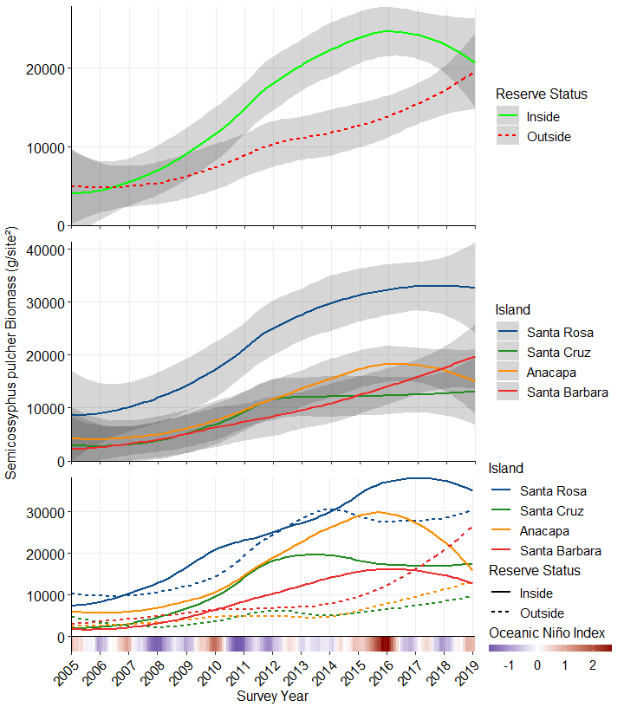 Fig 25. Semicossyphus pulcher (Sheephead) biomass by reserve status across all reference sites (Top), biomass by island across all reference sites (Middle), and FSC by island and reserve status across all reference sites (Bottom); gray intervals indicate 95% confidence ranges with LOESS smoothing. Oceanic Niño Index (ONI) is a measure of El Niño oscillation and strength, in units of *C.

## Kelp Bass Biomass

Our generalized linear mixed model indicated significant effects of MPA status (P=0), Island (P=0), and their interaction (P=0.001), but not ONI (Table 17.). Semicossyphus pulcher biomass was significantly higher inside MPAs from 2013-2017 (Fig 26. top), and the population with largest biomass occurs at Santa Rosa Island (Fig 26. middle). While populations at inside-MPA sites are beginning to show signs of declines, the respective populations outside MPAs at each island show recent signs of relative increases (Fig 26. bottom).

Table 17. GLMM Results

Model Formula: Kelp bass Biomass = Reserve Status * Island + ONI + (1 | Survey Year)

|  |  |  |  |  |
| --- | --- | --- | --- | --- |
|  | F | Df | Df.res | Pr(>F) |
| ReserveStatus | 25.351959 | 1 | 338 | 0.0000008 |
| IslandCode | 35.732423 | 3 | 338 | 0.0000000 |
| Mean_ONI_ANOM | 2.624783 | 1 | 13 | 0.1291994 |
| ReserveStatus:IslandCode | 4.858510 | 3 | 338 | 0.0025346 |

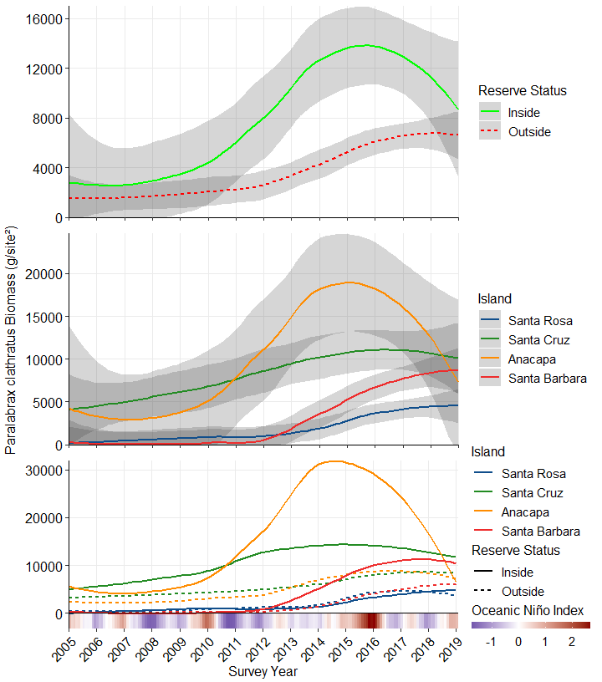 Fig 26. Paralabrax clathratus (kelp bass) biomass by reserve status across all reference sites (Top), biomass by island across all reference sites (Middle), and FSC by island and reserve status across all reference sites (Bottom); gray intervals indicate 95% confidence ranges with LOESS smoothing. Oceanic Niño Index (ONI) is a measure of El Niño oscillation and strength, in units of *C.

## Panulirus interruptus Density

Our generalized linear mixed model indicated significant effects of MPA status (P=0), Island (P=0), and their interaction (P=0), but not ONI (Table 18.). displayed distinct trends over time (Fig 27.). Panulirus interruptus populations are significantly larger inside MPAs (Fig 27. top), and at the greatest rate of increase occurred at Anacapa Island, although populations are growing at Santa Cruz and Santa Barbara islands. These population increases between islands are almost exclusively driven by inside-MPA populations at each island (Fig 27. bottom).

Table 18. GLMM Results

Model Formula: California spiny lobster density = Reserve Status * Island + ONI + (1 | Survey Year)

|  |  |  |  |  |
| --- | --- | --- | --- | --- |
|  | F | Df | Df.res | Pr(>F) |
| ReserveStatus | 73.154686 | 1 | 338 | 0.0000000 |
| IslandCode | 33.864499 | 3 | 338 | 0.0000000 |
| Mean_ONI_ANOM | 4.537803 | 1 | 13 | 0.0528291 |
| ReserveStatus:IslandCode | 30.497470 | 3 | 338 | 0.0000000 |

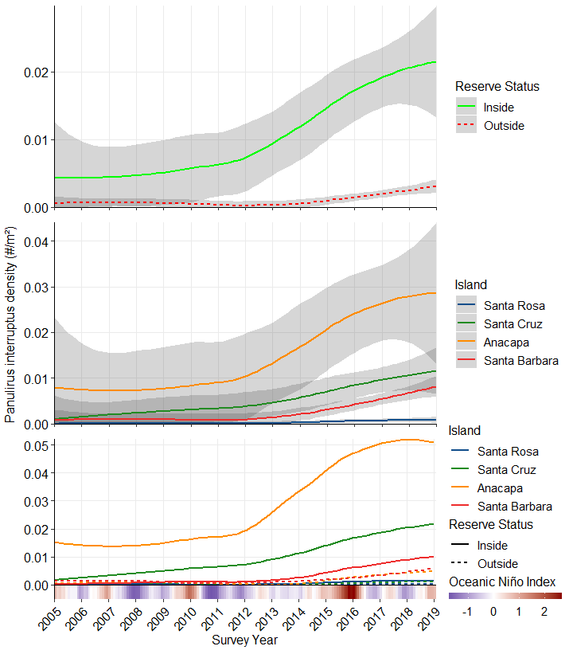 Fig 27. *Panulirus interruptus* (California spiny lobster) density by reserve status across all reference sites (A), by island across all reference sites (B), and by island and reserve status across all reference sites (C); gray intervals indicate 95% confidence ranges with LOESS smoothing. Oceanic Niño Index (ONI) is a measure of El Niño oscillation and strength, in units of *C.

*Panulirus interruptus* have a significant commercial trap fishery and are also targeted by recreational fishers. From the beginning of KFMP up until the implementation of the MPA network in 2003, *P. interruptus* numbers remained relatively stable. After the MPA network established protection of this highly targeted predator, densities began to rise at Anacapa Island, Santa Cruz Island, and Santa Barbara Islands. The largest increase can be seen inside the old Anacapa Island reserve which was expanded in 2003, however, densities went up universally inside and outside of the reserves (Fig 28.).

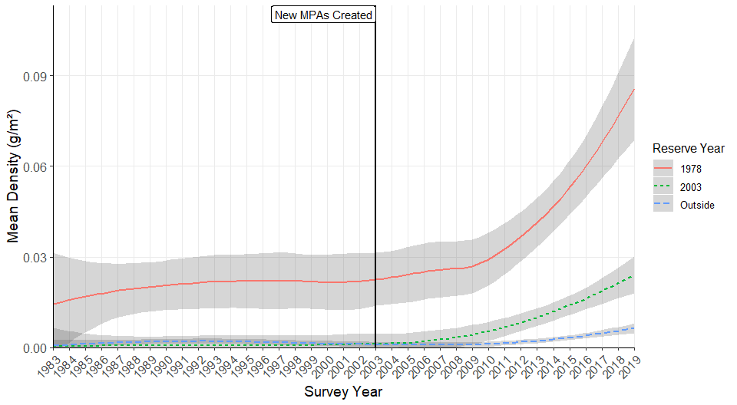 Fig 28. A comparison of Panulirus interruptus (California spiny lobster) density from the original 16 survey sites for the entirety of the Kelp Forest Monitoring Program, separated by reserve status. Landing and Cathedral Coves at Anacapa Island have been reserves since 1978, and were expanded along with the implementation of the remaining reserves in 2003.

## *Parastichopus parvimensis* Density

Our generalized linear mixed model indicated significant effects of MPA status (P=0), Island (P=0), their interaction (P=0), and of ONI (P=0; Table 19.). … trends over time (Fig 29.).

Table 19. GLMM Results

Model Formula: Warty sea cucumber density = Reserve Status * Island + ONI + (1 | Survey Year)

|  |  |  |  |  |
| --- | --- | --- | --- | --- |
|  | F | Df | Df.res | Pr(>F) |
| ReserveStatus | 110.610741 | 1 | 338 | 0.0000000 |
| IslandCode | 40.744392 | 3 | 338 | 0.0000000 |
| Mean_ONI_ANOM | 7.414149 | 1 | 13 | 0.0174165 |
| ReserveStatus:IslandCode | 16.682459 | 3 | 338 | 0.0000000 |

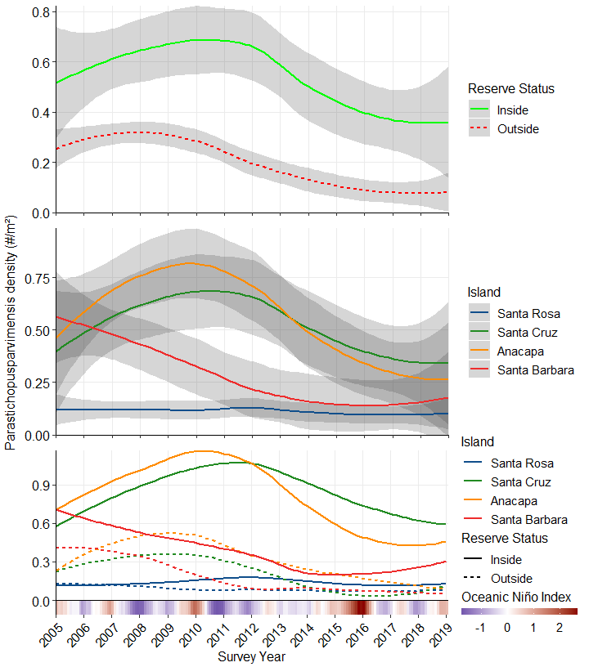 Fig 29. *Parastichopus parvimensis* (warty sea cucumber) density by reserve status across all reference sites (A), by island across all reference sites (B), and by island and reserve status across all reference sites (C); gray intervals indicate 95% confidence ranges with LOESS smoothing. Oceanic Niño Index (ONI) is a measure of El Niño oscillation and strength, in units of *C.

*Parastichopus parvimensis* have a significant commercial dive fishery and are also targeted by recreational divers. From the beginning of KFMP up until the dive fishery began in 1993 (**SOURCE**), *P. parvimensis* numbers remained relatively stable. After the dive fishery began, *P. parvimensis* numbers steadily declined in unprotected areas, while increasing in protected areas. After the implementation of the MPA network in 2003, numbers began to rise in the newly protected areas while staying continuing to decline in unprotected areas (Fig 30.). Numbers in the old Anacapa Island Reserve, established in 1978, began to decline to match the densities inside the newly made reserves.

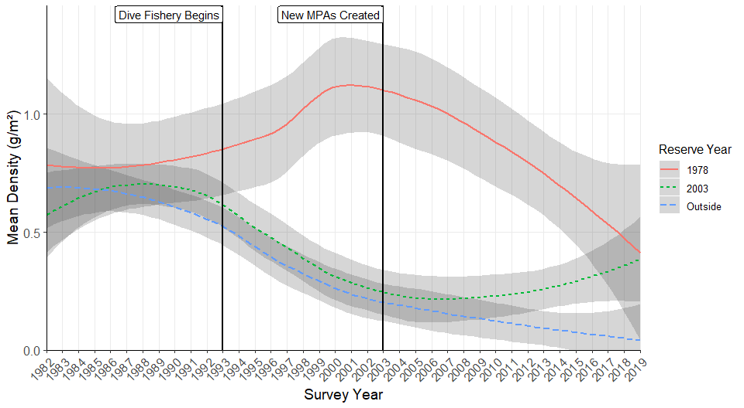 Fig 30. Cathedral Coves at Anacapa Island have been reserves since 1978, and were expanded along with the implementation of the remaining reserves in 2003. Beginning of the dive-based fishery in 1993 is shown.

## Centrostephanus coronatus Density

Our generalized linear mixed model indicated significant effects of MPA status (P=0.011), Island (P=0), their interaction (P=0.002), and with ONI (P=0.003; Table 20.). … trends over time (Fig 31.). More text will go here

Table 20. GLMM Results

Model Formula: Coronado urchin density = Reserve Status * Island + ONI + (1 | Survey Year)

|  |  |  |  |  |
| --- | --- | --- | --- | --- |
|  | F | Df | Df.res | Pr(>F) |
| ReserveStatus | 6.588427 | 1 | 338 | 0.0106944 |
| IslandCode | 27.055213 | 3 | 338 | 0.0000000 |
| Mean_ONI_ANOM | 13.496722 | 1 | 13 | 0.0028069 |
| ReserveStatus:IslandCode | 5.079420 | 3 | 338 | 0.0018804 |

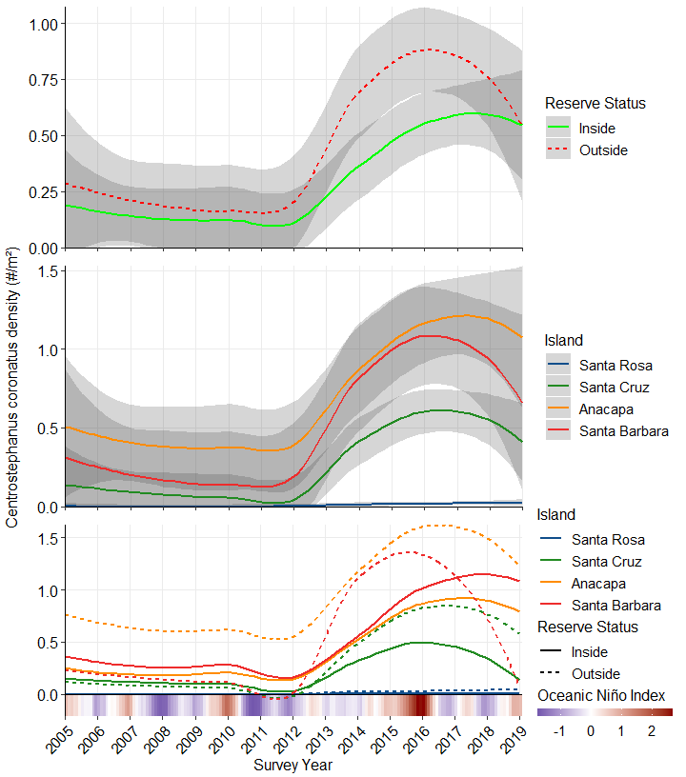 Fig 31. *Centrostephanus coronatus* (Coronado urchin) density by reserve status across all reference sites (A), by island across all reference sites (B), and by island and reserve status across all reference sites (C); gray intervals indicate 95% confidence ranges with LOESS smoothing. Oceanic Niño Index (ONI) is a measure of El Niño oscillation and strength, in units of *C.

## *Lophogorgia chilensis* Density

Our generalized linear mixed model indicated significant effects of MPA status (P=0.008), Island (P=0), and their interaction (P=0), but not of ONI (Table 21.). … over time (Fig 32.). More text will go here

Table 21. GLMM Results

Model Formula: Red Gorgonian = Reserve Status * Island + ONI + (1 | Survey Year)

|  |  |  |  |  |
| --- | --- | --- | --- | --- |
|  | F | Df | Df.res | Pr(>F) |
| ReserveStatus | 7.169546 | 1 | 338 | 0.0077771 |
| IslandCode | 103.621413 | 3 | 338 | 0.0000000 |
| Mean_ONI_ANOM | 1.959934 | 1 | 13 | 0.1849310 |
| ReserveStatus:IslandCode | 13.927474 | 3 | 338 | 0.0000000 |

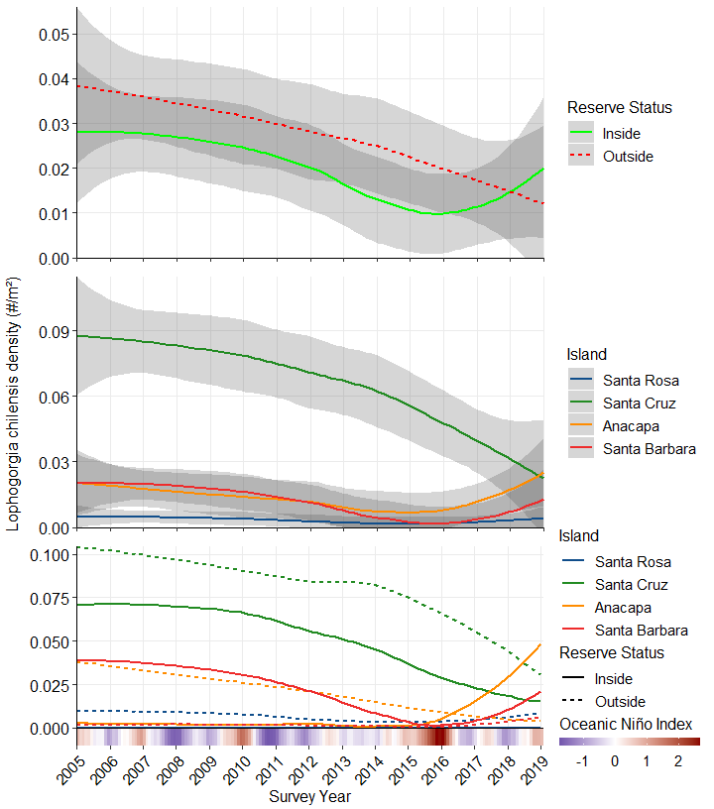 Fig 32. *Lophogorgia chilensis* (red gorgonian) density by reserve status across all reference sites (A), by island across all reference sites (B), and by island and reserve status across all reference sites (C); gray intervals indicate 95% confidence ranges with LOESS smoothing. Oceanic Niño Index (ONI) is a measure of El Niño oscillation and strength, in units of *C.

## Percent Cover

### *Cystoseira* sp. Cover

Our generalized linear mixed model indicated significant effects of MPA status (P=0), Island (P=0), and their interaction (P=0), but not ONI (Table 22.). Populations were significantly larger inside MPAs (Fig 33. top), and while populations at Anacapa, Santa Cruz, and Santa Rosa Islands have been stable, Santa Barbara Island has experienced significant increases in *Cystoseira* sp. cover since 2013 (Fig 33. middle).

Table 22. GLMM Results

Model Formula: Cystoseira = Reserve Status * Island + ONI + (1 | Survey Year)

|  |  |  |  |  |
| --- | --- | --- | --- | --- |
|  | F | Df | Df.res | Pr(>F) |
| ReserveStatus | 45.366558 | 1 | 338 | 0.0000000 |
| IslandCode | 8.074092 | 3 | 338 | 0.0000329 |
| Mean_ONI_ANOM | 2.440076 | 1 | 13 | 0.1422771 |
| ReserveStatus:IslandCode | 7.890157 | 3 | 338 | 0.0000421 |

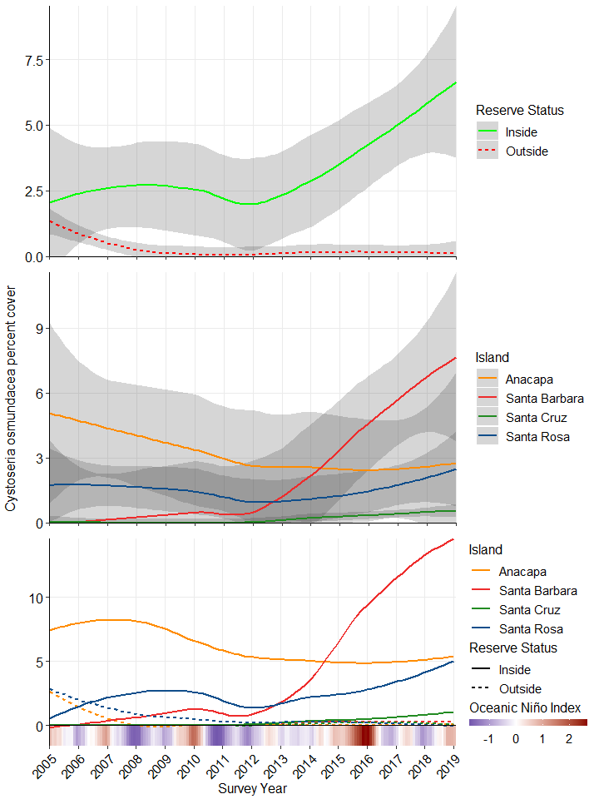 Fig 33. *Cystoseira osmundacea* (bladderchain kelp) density by reserve status across all reference sites (top), by island across all reference sites (middle), and by island and reserve status across all reference sites (bottom); gray intervals indicate 95% confidence ranges with LOESS smoothing. Oceanic Niño Index (ONI) is a measure of El Niño oscillation and strength, in units of *C.

### Articulated coralline algae Cover

Our generalized linear mixed model indicated significant effects of MPA status (P=0), Island (P=0), and their interaction (P=0), but not ONI (Table 23.). Populations were significantly larger inside MPAs (Fig 34. top), and while populations at Anacapa, Santa Cruz, and Santa Rosa Islands have been stable, Santa Barbara Island has experienced significant increases in articulated coralline cover since 2013 (Fig 34. middle).

Model Formula: articulated coralline algae = Reserve Status * Island + ONI + (1 | Survey Year)

|  |  |  |  |  |
| --- | --- | --- | --- | --- |
|  | F | Df | Df.res | Pr(>F) |
| ReserveStatus | 30.508325 | 1 | 338 | 0.0000001 |
| IslandCode | 9.708892 | 3 | 338 | 0.0000037 |
| Mean_ONI_ANOM | 3.528722 | 1 | 13 | 0.0829228 |
| ReserveStatus:IslandCode | 6.929533 | 3 | 338 | 0.0001540 |

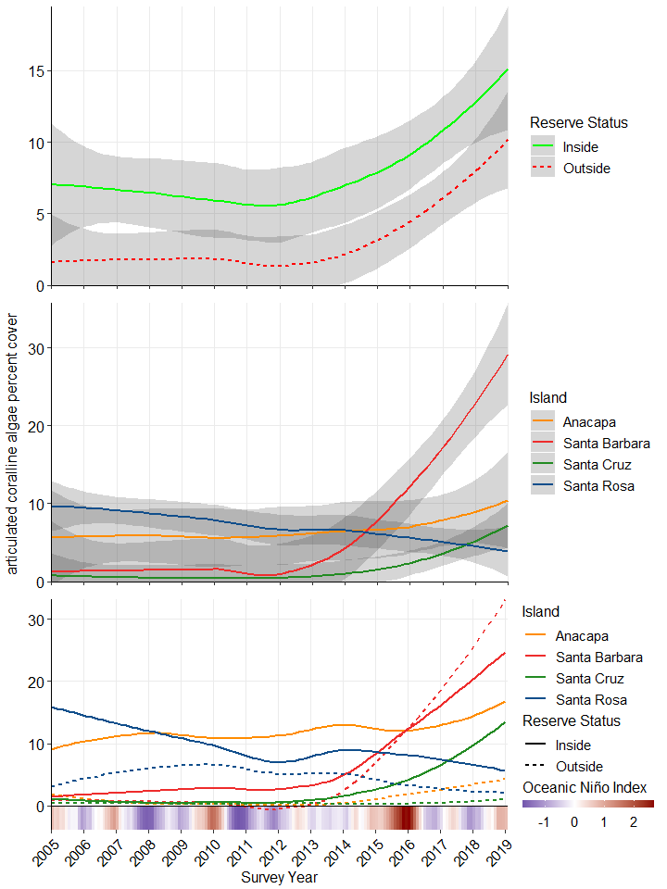 Fig 34. Articulated coralline algae

## Benthic Biomass Summary

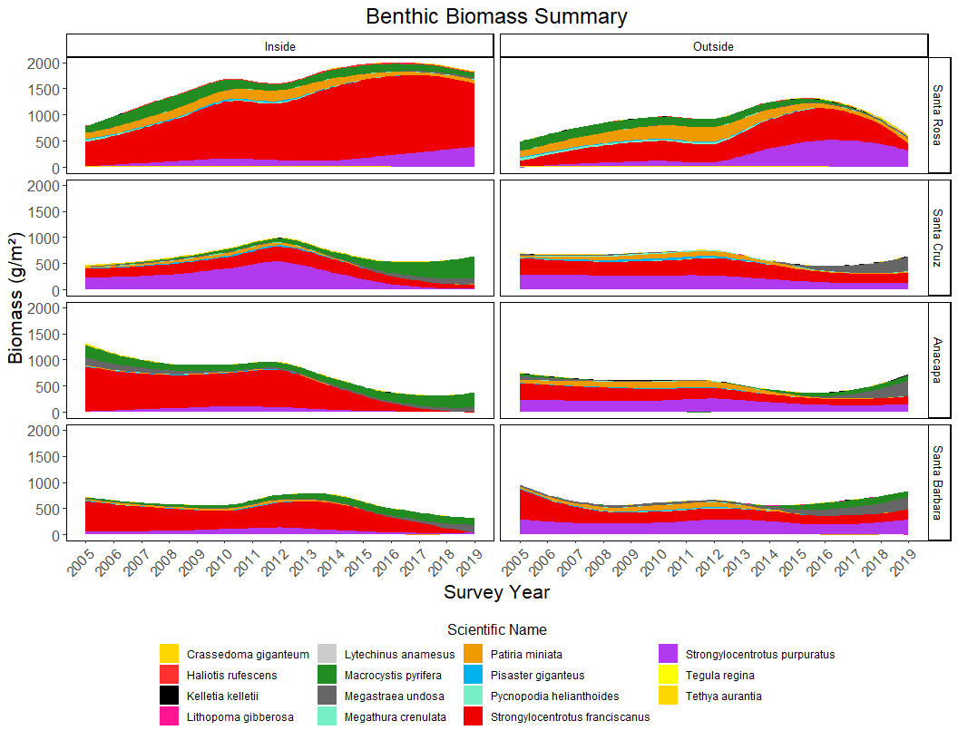 Fig 35. ## Fish Biomass Summary

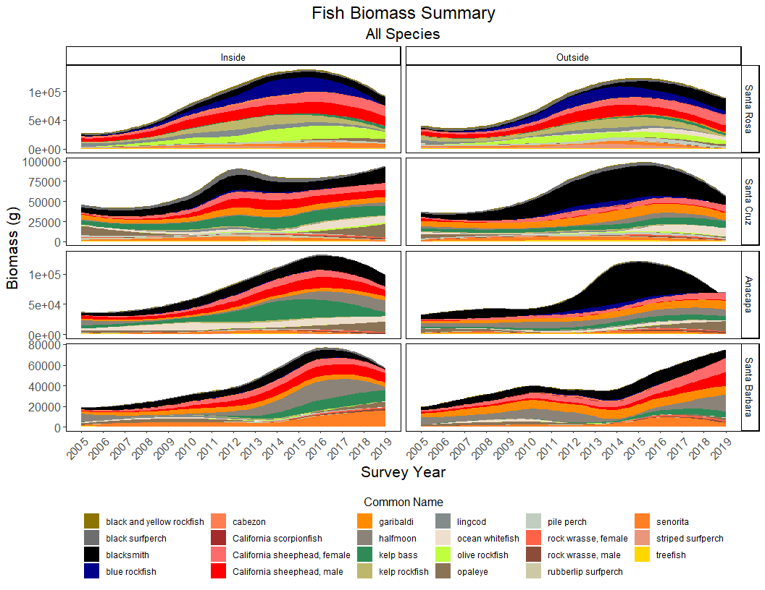 Fig 36. Biomass of 21 species of fish. California sheephead and rock wrasse are split into males and females.

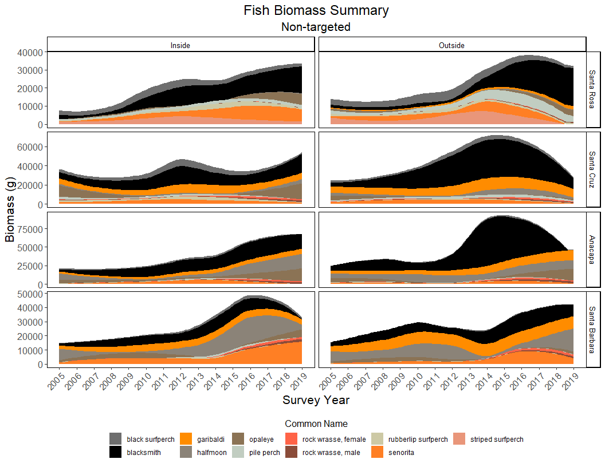 Fig 37. Biomass of 10 non-targeted species of fish. Rock wrasse are split into males and females.

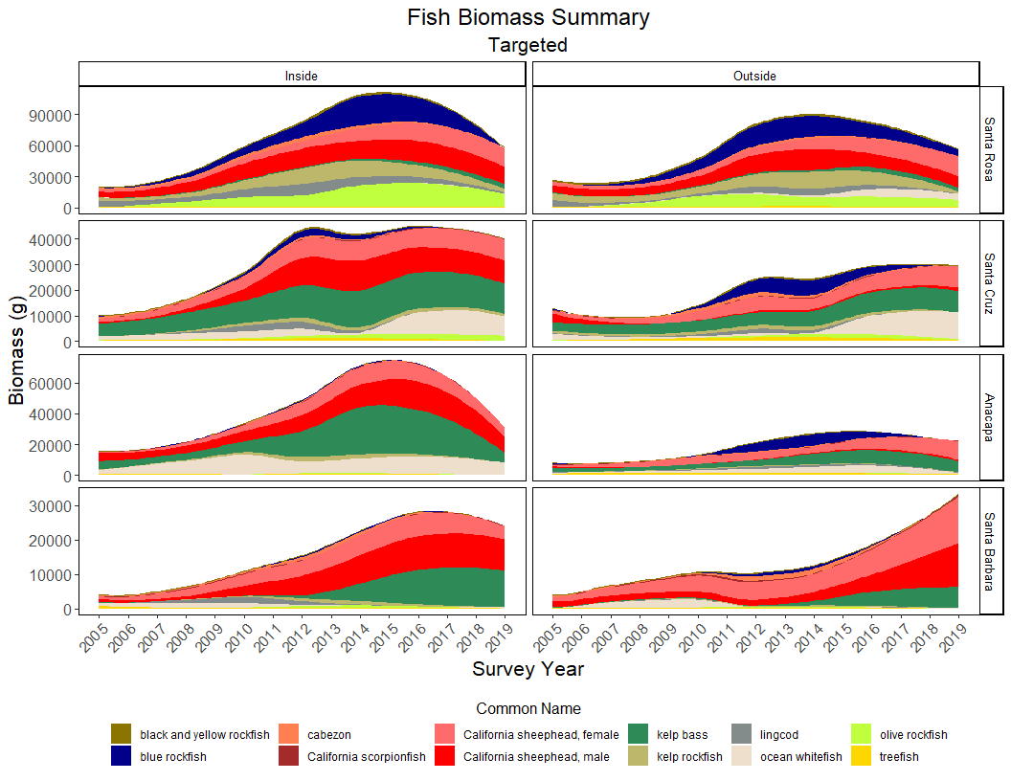 Fig 38. Biomass of 11 targeted species of fish. California sheephead are split into males and females.

# Discussion

Diversity differences – Recent significant increase inside of MPAs, SR recently decreasing while other islands increasing

Similarity differences - SR distinct 2005-2010, all islands similar 2010-2015, SR distinct again 2016-2019

Biomass trends of species identified in ISA are consistent with other observations in CA kelp forests (kelp deforestation, urchin proliferation, sea star and abalone declines) in the previous decade

Species interactions and biomass/density trends trends…

* Trend in sea stars and 2013-2014 SSWD
* pre blob/El Niño major decline, then blob = perfect storm
* Santa Rosa Island
  + ISA show Pycnopodia as an indicator inside and outside at Santa Rosa up to 2013
  + Purple urchins identified by ISA in 2015 inside and 2016 outside and continue to be identified after.
  + Red urchins identified by ISA in 2015 inside and 2018 outside
  + Pycnopodia last predator left at Santa Rosa, when they go, there is nothing left to effectively control urchins
  + Biomass of sheep head goes up inside and out, with increase in urchins
  + Main driver for decrease in diversity at SR
  + Inside stays more diverse indicating MPA resiliency when confronted with major changes
  + Urchin biomass increases dramatically as kelp biomass decreases dramitically esp. outside reserve
  + Red abalone biomass increases initially (increased competition, more foraging)
  + decline later when urchin biomass peaks (out competed)
  + Kelp no longer identified by ISA outside reserve post 2014, indicates dominance of urchins and impact on kelp
  + Tethya have major decline with latest warm water event
    - Could be strong correlation with PDO phases (most effected at Santa Rosa)
* Santa Cruz/Anacapa/Santa Barbara
* Santa Cruz/Anacapa
* General interactions
  + Garibaldi never indicate inside-MPA communities, only outside, and have significantly higher biomass outside. Perhaps reduced competition due to fishing pressure?
  + Halfmoon and opaleye (herbiverous fish) have higher inside/outside biomass ratio where algaes tend to be more plentiful
    - reference ratio plot and RPC algal cover plots

Fisheries effects - Lobster and Warty Cucumber - with original 16 plot set showing the effects of old reserves at ANI vs new reserves. I want to use these two examples to draw out points about resiliency, edge effects and “effective MPA size”, and larval connectivity

Prior to the new reserve implementation, spiny lobsters exhibited a relatively stable population that was larger inside the old reserves than outside, it’s also worth noting that these old reserves were expanded with the implementation of the new reserves, and following that we see increases across the board (including a small one outside the reserves), but the greatest increase occurs in these oldest MPAs. This is consistent with the notion that edge effects in smaller MPAs are proportionally higher, and leave a proportionally smaller inside area “truly” protected, as well as the notion that the older an MPA is, the higher the resiliency of its community. Lobster are also an important predator of urchins, whose herbivory has major impacts on kelp abundance and biomass. In the coming weeks we’ll show you some more species, including kelp, urchins, and sunflower stars (another important urchin predator), but according to our random forest analysis, spiny lobster are one of the two most important species in identifying whether a community is from inside or outside an MPA.

Warty sea cucumber are another interesting species for the region, since it had a diving-based fishery begin in the early 1990s, although harvesting began prior to that year. We can see here that the abundance of warty sea cucumbers was relatively even between inside and outside- MPA communities, until the beginning of the fishery, where the outside (at the time) MPA sites experienced a steady decline, as the protected areas saw increases in abundance. If you stop in 2001, this is a fairly standard story about fishery effects – however, the interesting part of this species’ trend is that, rather than staying relatively consistent, as it appears to pre-fishery, the inside-MPAs experience an initial increase, followed by a decline approximately to the level of the new MPAs, while the new MPAs are beginning to show an increase in density, and the outside reserve sites continue to decline. For many marine species that have a long larval period, recruitment is not very site-specific, and larval connectivity in the metapopulation as a whole is important for recruitment and population consistency, so this trend is likely due to overall reductions in larval abundance available for recruitment, due to smaller spawning populations outside MPAs. While the new MPAs also show signs of resilience and recovery in this case, warty sea cucumbers highlight the importance of these interconnected communities inside and outside MPAs, and thus that conditions and events outside of MPAs are still capable of affecting those inside.

# Literature Cited

Canty A, Ripley BD (2020). boot: Bootstrap R (S-Plus) Functions. R package version 1.3-25.

Davison AC, Hinkley DV (1997). Bootstrap Methods and Their Applications. Cambridge University Press, Cambridge. ISBN 0-521-57391-2, <http://statwww.epfl.ch/davison/BMA/>.

De Caceres, M., Legendre, P. (2009). Associations between species and groups of sites: indices and statistical inference. Ecology, URL <http://sites.google.com/site/miqueldecaceres/>

Douglas Bates, Martin Maechler, Ben Bolker, Steve Walker (2015). Fitting Linear Mixed-Effects Models Using lme4. Journal of Statistical Software, 67(1), 1-48. <doi:10.18637/jss.v067.i01>.

Dufrêne, M. & Legendre, P. (1997) Species assemblages and indicator species: the need for a flexible asymmetrical approach. Ecological Monographs, 67, 345–366. Rassweiler et al 2018 - conversions to kelp biomass

McGeoch, M.A. & Chown, S.L. (1998) Scaling up the value of bioindicators. Trends in Ecology & Evolution, 13, 46–47.

Jari Oksanen, F. Guillaume Blanchet, Michael Friendly, Roeland Kindt, Pierre Legendre, Dan McGlinn, Peter R. Minchin, R. B. O’Hara, Gavin L. Simpson, Peter Solymos, M. Henry H. Stevens, Eduard Szoecs and Helene Wagner (2019). vegan: Community Ecology Package. R package version 2.5-6. <https://CRAN.R-project.org/package=vegan>

NEED TO CITE

* ONI data
* PDO data ? if we use it
* PISCO fish data 2005-2006 ? if we use it

# Appendix A. Biomass Ratios

See bootstrapping description in methods. I’m sorry that we didn’t make it this far with the state of our draft, but this is something fundamental that will need to be discussed compared to how these have been presented previously. Specifically, standard error allow for eyeball comparison of error bars between groups (ie are two means + ranges significantly different from each other), but NOT whether a mean/range is significantly different from a given number, which requires 95% CIs, and by grouping across multiple years the parametric assumption of independent samples is violated even when converted to log ratios, which artificially inflates the sample size since SE is SD/sqrt(sample size)). Further, since calculating ratios within a year only allows an n=4 (one ratio per island, based off the average biomass inside and outside from each pair of three sites) these result in error bars massively overestimating the range, but bootstrapping the data allows us to non-parametrically estimate the underlying distribution based on resampling individual site biomasses, not averaging averages for each level of reserve status.

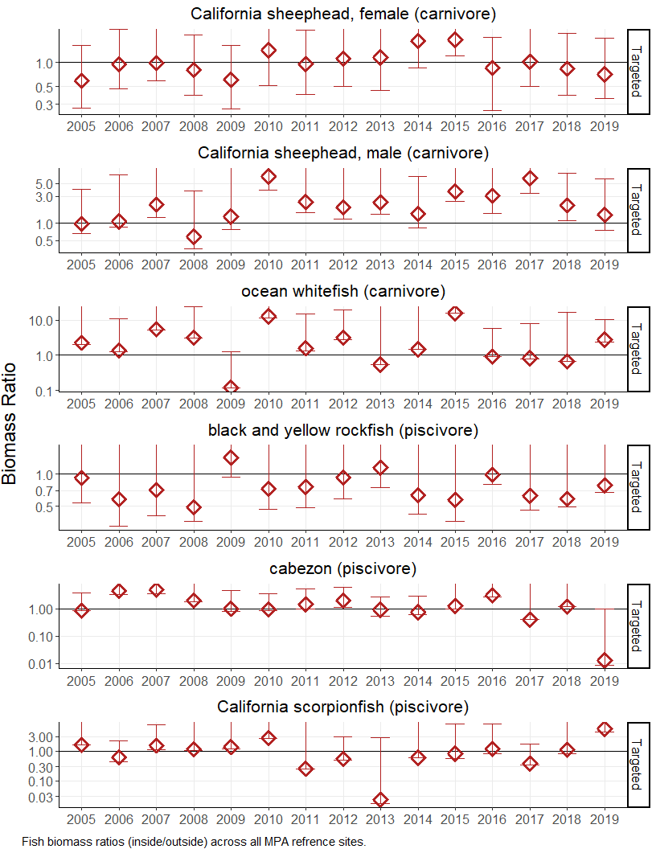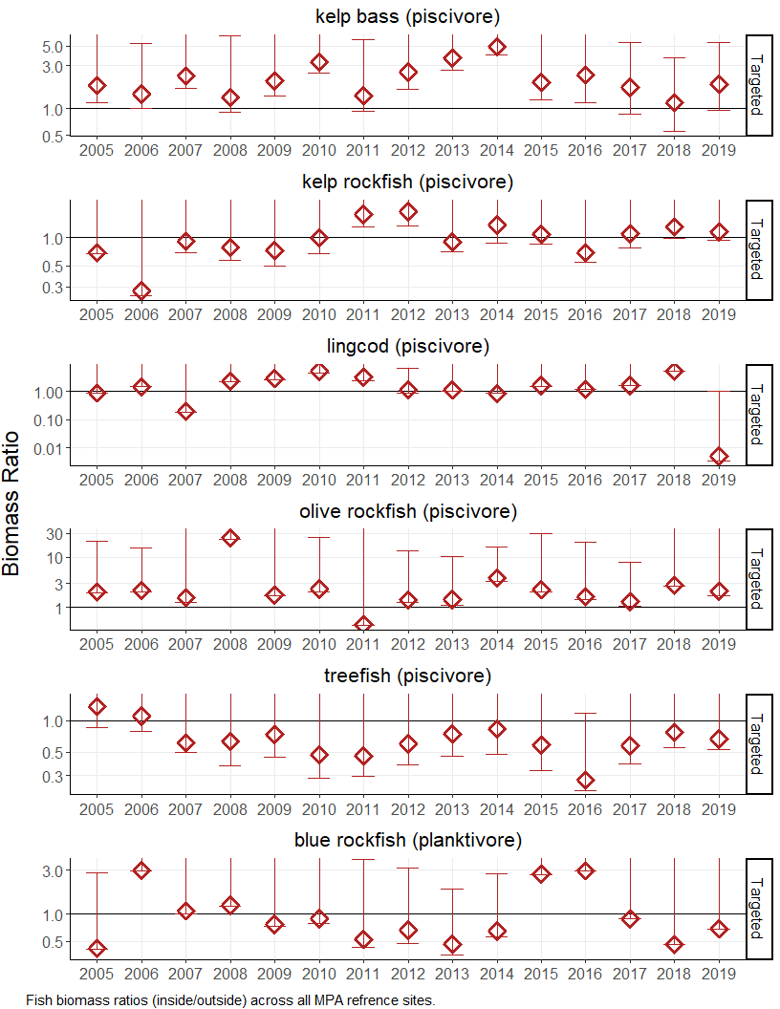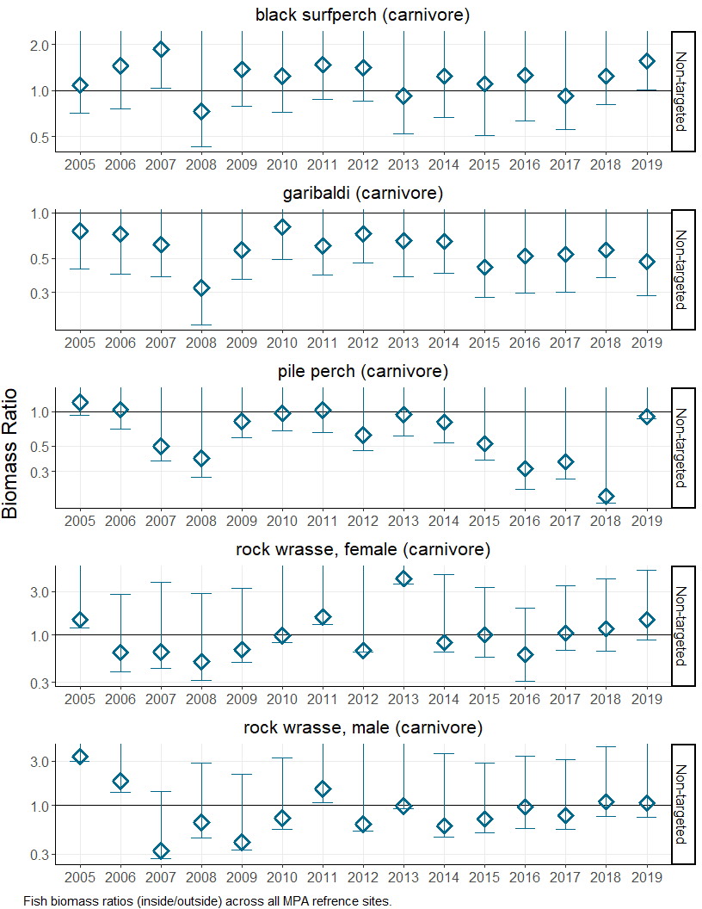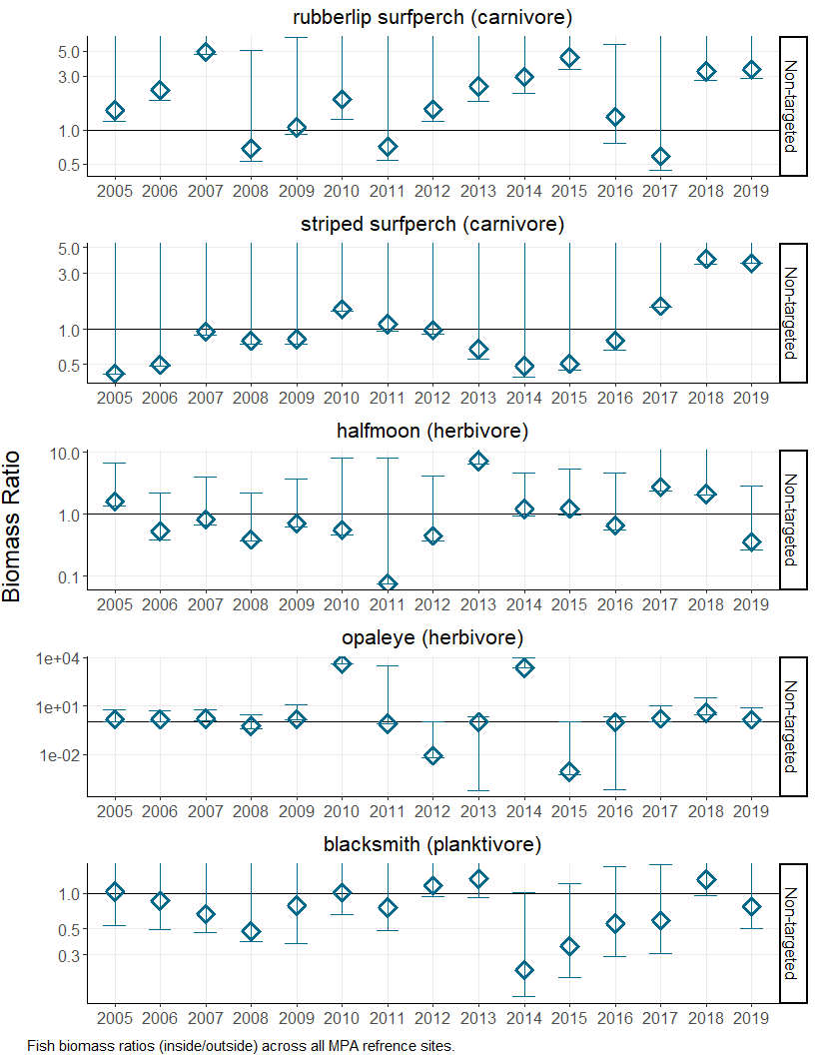

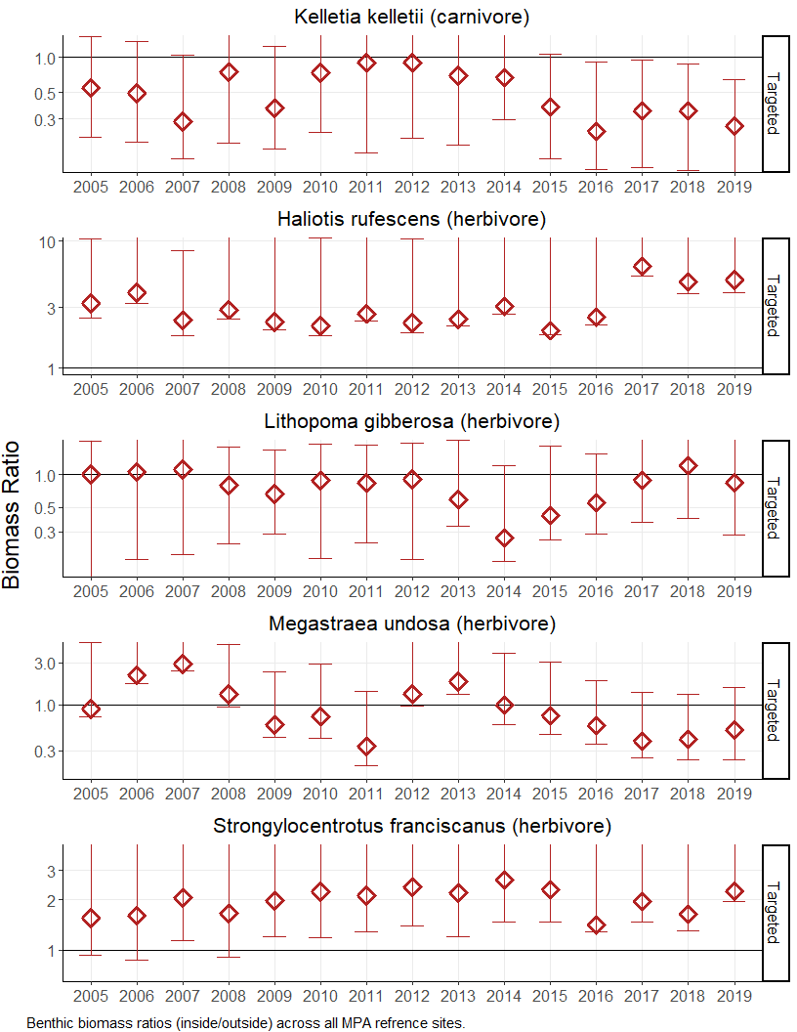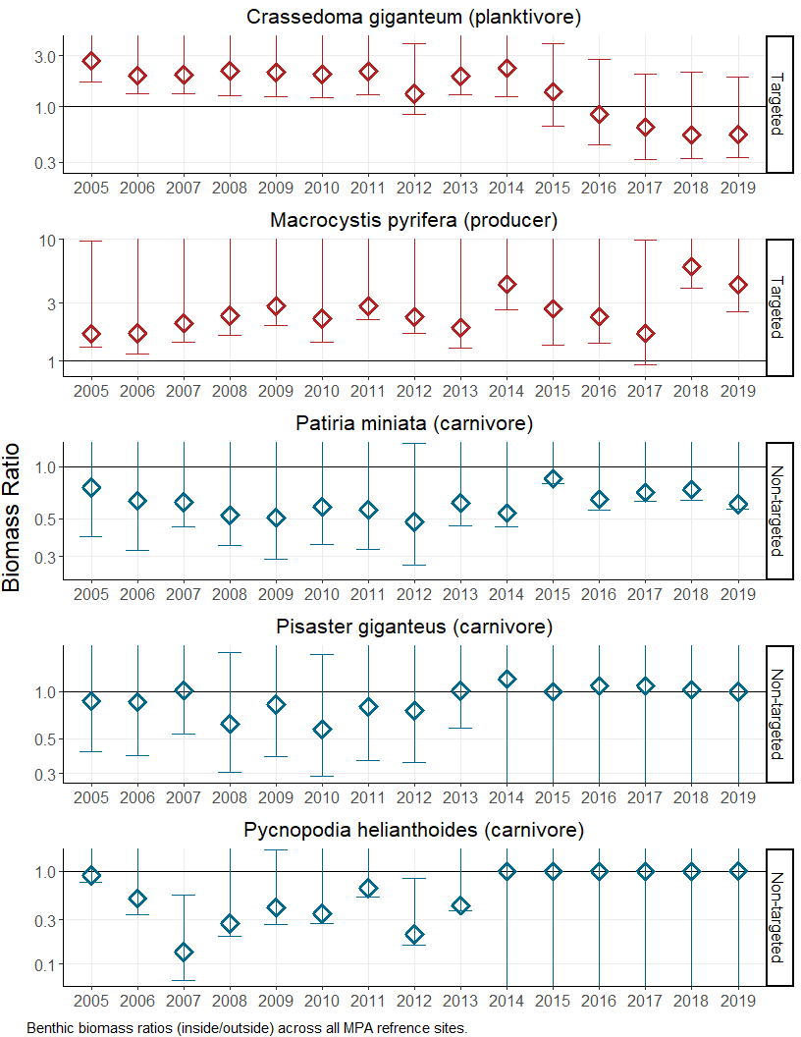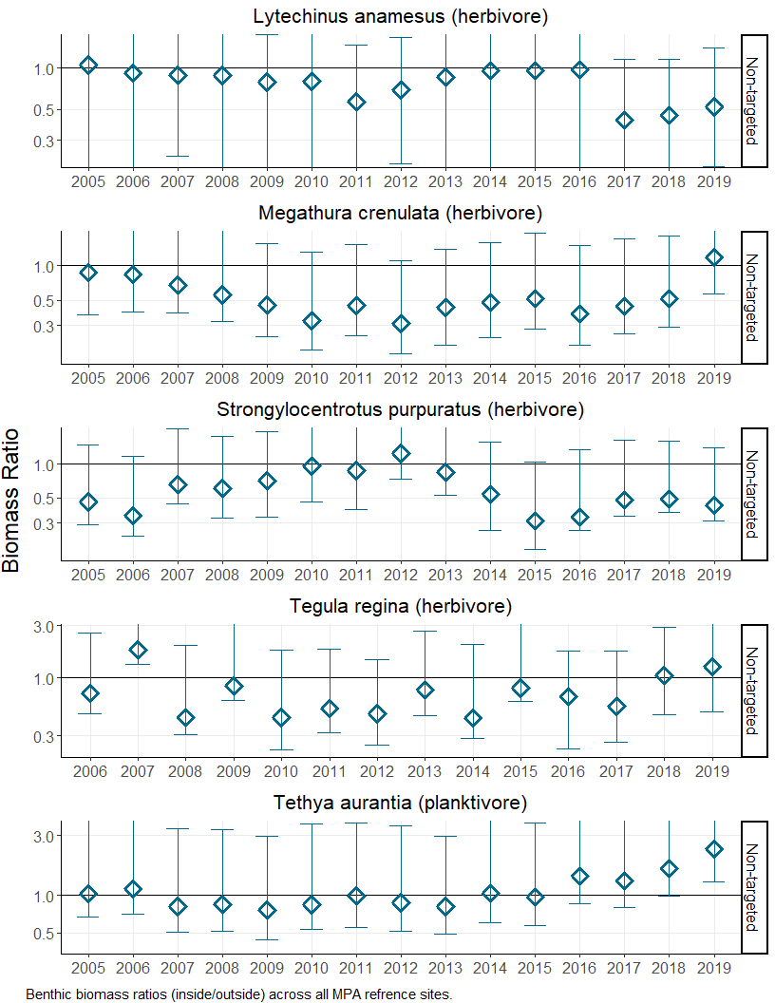

# Appendix B. KFMP Metadata

Table XX. Kelp Forest Monitoring Program sampling sites information.

|  |  |  |  |  |  |  |  |  |  |  |  |
| --- | --- | --- | --- | --- | --- | --- | --- | --- | --- | --- | --- |
| Site # | Island Name | Site Name | Depth Range | Est. | MPA Est. | Reference | Latitude | Longitude | Percent Rock | Percent Cobble | Percent Sand |
| 1 | San Miguel | Wyckoff Ledge | 13-15 m | 1982 | N/A | FALSE | 34.02237 | -120.3875 | 73.48 | 3.69 | 22.07 |
| 2 | San Miguel | Hare Rock | 6-9 m | 1982 | 2003 | FALSE | 34.06438 | -120.3566 | 80.22 | 14.67 | 4.91 |
| 21 | San Miguel | Miracle Mile | 7-10 m | 2001 | N/A | FALSE | 34.02370 | -120.3951 | 87.24 | 7.04 | 5.72 |
| 3 | Santa Rosa | Johnson’s Lee North | 9-11 m | 1982 | N/A | TRUE | 33.90147 | -120.1030 | 93.81 | 2.46 | 3.66 |
| 4 | Santa Rosa | Johnson’s Lee South | 14-16 m | 1982 | N/A | TRUE | 33.89753 | -120.1008 | 79.23 | 2.74 | 17.99 |
| 5 | Santa Rosa | Rodes Reef | 13-15 m | 1983 | N/A | FALSE | 34.03262 | -120.1070 | 82.55 | 11.80 | 5.34 |
| 22 | Santa Rosa | Cluster Point | 12-15 m | 2005 | N/A | TRUE | 33.92303 | -120.1874 | 85.62 | 7.84 | 6.53 |
| 23 | Santa Rosa | Trancion Canyon | 9-15 m | 2005 | 2003 | TRUE | 33.90855 | -120.1555 | 85.79 | 2.19 | 12.02 |
| 24 | Santa Rosa | Chickasaw | 10-13 m | 2005 | 2003 | TRUE | 33.90037 | -120.1357 | 84.52 | 0.74 | 14.73 |
| 25 | Santa Rosa | South Point | 11-13 m | 2005 | 2003 | TRUE | 33.89233 | -120.1195 | 81.76 | 0.87 | 17.38 |
| 6 | Santa Cruz | Gull Island South | 14-16 m | 1982 | 2003 | FALSE | 33.94967 | -119.8276 | 94.36 | 2.20 | 3.37 |
| 7 | Santa Cruz | Fry’s Harbor | 12-13 m | 1982 | N/A | FALSE | 34.05106 | -119.7552 | 82.14 | 11.15 | 4.57 |
| 8 | Santa Cruz | Pelican Bay | 6-8 m | 1982 | N/A | FALSE | 34.03488 | -119.7031 | 55.34 | 16.20 | 28.08 |
| 9 | Santa Cruz | Scorpion Anchorage | 5-6 m | 1982 | 2003 | TRUE | 34.04798 | -119.5514 | 82.45 | 4.79 | 12.67 |
| 10 | Santa Cruz | Yellowbanks | 14-15 m | 1986 | N/A | FALSE | 33.98983 | -119.5631 | 75.60 | 15.62 | 8.78 |
| 26 | Santa Cruz | Devil’s Peak Member | 10-13 m | 2005 | N/A | TRUE | 34.04488 | -119.6013 | 91.81 | 4.09 | 4.10 |
| 27 | Santa Cruz | Potato Pasture | 9-12 m | 2005 | 2003 | TRUE | 34.05217 | -119.5821 | 84.27 | 12.07 | 3.67 |
| 28 | Santa Cruz | Cavern Point | 12-13 m | 2005 | 2003 | TRUE | 34.05428 | -119.5669 | 87.57 | 8.29 | 4.14 |
| 29 | Santa Cruz | Little Scorpion | 9-14 m | 2005 | N/A | TRUE | 34.04415 | -119.5425 | 83.20 | 12.63 | 4.17 |
| 30 | Santa Cruz | Pedro Reef | 7-10 m | 2005 | N/A | TRUE | 34.03837 | -119.5253 | 85.43 | 2.62 | 11.94 |
| 11 | Anacapa | Admiral’s Reef | 13-15 m | 1982 | N/A | TRUE | 34.00775 | -119.4344 | 84.42 | 7.21 | 8.49 |
| 12 | Anacapa | Cathedral Cove | 6-11 m | 1982 | 1979 | TRUE | 34.01587 | -119.3717 | 65.47 | 20.16 | 14.36 |
| 13 | Anacapa | Landing Cove | 5-12 m | 1982 | 1979 | TRUE | 34.01703 | -119.3611 | 71.89 | 18.56 | 9.45 |
| 31 | Anacapa | Keyhole | 7-10 m | 2005 | 2003 | TRUE | 34.01642 | -119.4320 | 75.96 | 12.70 | 11.34 |
| 32 | Anacapa | East Fish Camp | 9-14 m | 2005 | N/A | TRUE | 34.00450 | -119.3858 | 88.41 | 3.88 | 7.71 |
| 33 | Anacapa | Black Sea Bass Reed | 15-16 m | 2005 | 2003 | TRUE | 34.01260 | -119.3892 | 85.91 | 10.84 | 3.24 |
| 34 | Anacapa | Lighthouse | 7-9 m | 2005 | N/A | TRUE | 34.01410 | -119.3590 | 73.39 | 9.07 | 17.54 |
| 14 | Santa Barbara | Southeast Sea Lion Rookery | 12-14 m | 1982 | 2003 | TRUE | 33.46612 | -119.0278 | 83.29 | 6.03 | 10.50 |
| 15 | Santa Barbara | Arch Point | 7-8 m | 1982 | N/A | TRUE | 34.00775 | -119.4344 | 84.42 | 7.21 | 8.49 |
| 16 | Santa Barbara | Cat Canyon | 7-9 m | 1986 | N/A | TRUE | 33.46442 | -119.0392 | 87.80 | 3.50 | 8.70 |
| 35 | Santa Barbara | Webster’s Arch | 14-16 m | 2005 | N/A | TRUE | 33.47985 | -119.0622 | 95.71 | 4.00 | 0.29 |
| 36 | Santa Barbara | Graveyard Canyon | 10-12 m | 2005 | 2003 | TRUE | 33.47307 | -119.0268 | 59.91 | 4.06 | 36.03 |
| 37 | Santa Barbara | Southeast Reef | 10-15 m | 2005 | 2003 | TRUE | 33.46293 | -119.0313 | 90.23 | 5.99 | 3.78 |

# Appendix C. Regularly monitored species, substrate, and associated monitoring technique(s). Monitoring techniques are described in Davis et al., 1997, and Kushner and Sprague, in progress.

|  |  |  |  |  |  |  |  |  |  |
| --- | --- | --- | --- | --- | --- | --- | --- | --- | --- |
| Group | Taxa/Common Name | Scientific Name | 1 m | 5 m | Bands | RPCs | NHSF | VFT | RDFC |
| Algae | Miscellaneous green algae | NA | NA | NA | NA | 1982-present | NA | NA | NA |
| Algae | Miscellaneous red algae | NA | NA | NA | NA | 1982-present | NA | NA | NA |
| Algae | Articulated coralline algae | NA | NA | NA | NA | 1982-present | NA | NA | NA |
| Algae | Encrusting coralline algae | NA | NA | NA | NA | 1982-present | NA | NA | NA |
| Algae | Agar weed | Gelidium spp. | NA | NA | NA | 1982-present | NA | NA | NA |
| Algae | Sea tongue | Gigartina spp. | NA | NA | NA | 1982-present | NA | NA | NA |
| Algae | Miscellaneous brown algae | NA | NA | NA | NA | 1982-present | NA | NA | NA |
| Algae | Acid weed | Desmarestia spp. | NA | NA | NA | 1982-present | NA | NA | NA |
| Algae | Oar weed | Laminaria farlowii | 1996-present | NA | NA | 1982-present | NA | NA | NA |
| Algae | Bladder chain kelp | Cystoseira spp. | NA | NA | NA | 1982-present | NA | NA | NA |
| Algae | Giant kelp | Macrocystis pyrifera | 1983-present | 1996-present | NA | 1993-present | NA | NA | NA |
| Algae | California sea palm | Pterygophora californica | 1996-present | NA | NA | 1993-present | NA | NA | NA |
| Algae | Southern sea palm | Eisenia arborea | 1996-present | NA | NA | 1993-present | NA | NA | NA |
| Algae | Devil weed | Sargassum horneri | 2010-present | 2010-present | 2010-present | 2010-present | NA | NA | NA |
| Algae | Wakame | Undaria pinnatifida | 2016-present | 2016-present | 2016-present | N/A | NA | NA | NA |
| Algae | Miscellaneous plants | NA | NA | NA | NA | 1982-present | NA | NA | NA |
| Invertebrates | Miscellaneous sponges | NA | NA | NA | NA | 1985-present | NA | NA | NA |
| Invertebrates | Orange puffball sponge | Tethya aurantia | NA | NA | 1983-present | NA | X | NA | NA |
| Invertebrates | Southern staghorn bryozoan | Diaperoecia californica | NA | NA | NA | 1982-present | NA | NA | NA |
| Invertebrates | Miscellaneous bryozoans | NA | NA | NA | NA | 1985-present | NA | NA | NA |
| Invertebrates | California hydrocoral | Stylaster californica | NA | NA | 1983-present | NA | X | NA | NA |
| Invertebrates | White-spotted rose anemone | Tealia lofotensis | NA | NA | 1983-present | NA | NA | NA | NA |
| Invertebrates | Red gorgonian | Lophogorgia chilensis | NA | NA | 1983-present | NA | X | NA | NA |
| Invertebrates | Brown gorgonian | Muricea fruticosa | NA | NA | 1983-present | NA | X | NA | NA |
| Invertebrates | Californian golden gorgonian | Muricea californica | NA | NA | sporadically 1988-1990, continuously 1991-present | NA | X | NA | NA |
| Invertebrates | Strawberry anemone | Corynactis californica | NA | NA | NA | 1982-present | NA | NA | NA |
| Invertebrates | Orange cup coral | Balanophyllia elegans | NA | NA | NA | 1982-present | NA | NA | NA |
| Invertebrates | Cup coral | Astrangia lajollaensis | NA | NA | NA | 1982-present | NA | NA | NA |
| Invertebrates | Ornate tube worm | Diopatra ornata | NA | NA | NA | 1982-present | NA | NA | NA |
| Invertebrates | Colonial sand-tube worm | Phragmatopoma californica | NA | NA | NA | 1982-present | NA | NA | NA |
| Invertebrates | Scaled-tube snail | Serpulorbis s1 m Quadsuamigerus | NA | NA | NA | 1982-present | NA | NA | NA |
| Invertebrates | Chestnut cowrie | Cypraea spadicea | 1983-present, except for ANAR and SRRR 1982-present | NA | NA | NA | NA | NA | NA |
| Invertebrates | Wavy turban snail | Megastraea undosa | 1982-present | NA | NA | NA | 1985-present | NA | NA |
| Invertebrates | Red turban snail | Astraea gibberosa | 1985-present | NA | NA | NA | X | NA | NA |
| Invertebrates | Queen Tegula | Tegula Regina | 2006-present | NA | NA | NA | 2006-present | NA | NA |
| Invertebrates | Bat star | Patiria miniata | 1982-present | NA | NA | NA | X | NA | NA |
| Invertebrates | Giant-spined sea star | Pisaster giganteus | 1982-present | 1996-present | 2014-present | NA | X | NA | NA |
| Invertebrates | Ochre sea star | Pisaster ochraceus | NA | 2012-present | 2014-present | NA | X | NA | NA |
| Invertebrates | Sunflower star | Pycnopodia helianthoides | X | NA | 1983-present | NA | X | NA | NA |
| Invertebrates | White sea urchin | Lytechinus anamesus | NA | NA | 1983-present | NA | X | NA | NA |
| Invertebrates | Red sea urchin | Strongylocentrotus franciscanus | 1982-present | NA | NA | NA | X | NA | NA |
| Invertebrates | Purple sea urchin | Strongylocentrotus purpuratus | 1982-present | NA | NA | NA | X | NA | NA |
| Invertebrates | Warty sea cucumber | Parastichopus parvimensis | 1982-present (except for no data SCPB in 1988) | NA | NA | NA | NA | NA | NA |
| Invertebrates | Aggregated red sea cucumber | Pachythyone rubra | NA | NA | NA | continuously 1982-1984, sporadically 1984-1990, continuously 1991-present | NA | NA | NA |
| Invertebrates | Red abalone | Haliotis rufescens | NA | NA | 1983-present | NA | X | NA | NA |
| Invertebrates | Pink abalone | Haliotis corrugata | NA | NA | 1983-present | NA | X | NA | NA |
| Invertebrates | Green abalone | Haliotis fulgens | NA | NA | 1983-present | NA | X | NA | NA |
| Invertebrates | Kellett<U+0092>s whelk | Kelletia kelletii | NA | NA | 1983-present | NA | X | NA | NA |
| Invertebrates | Giant keyhole limpet | Megathura crenulata | NA | NA | 1983-present | NA | X | NA | NA |
| Invertebrates | Gumboot Chiton | Cryptochiton stelleri | NA | NA | 2012-present | NA | NA | NA | NA |
| Invertebrates | California brown sea hare | Aplysia california | NA | NA | 1983-present | NA | NA | NA | NA |
| Invertebrates | Rock scallop | Crassedoma giganteum | NA | NA | 1983-present | NA | X | NA | NA |
| Invertebrates | California spiny lobster | Panulirus interruptus | NA | NA | 1983-present | NA | NA | NA | NA |
| Invertebrates | Tunicates | NA | NA | NA | NA | 1982-present | NA | NA | NA |
| Invertebrates | Stalked tunicate | Styela montereyensis | 1982-present | NA | NA | NA | NA | NA | NA |
| Invertebrates | Miscellaneous invertebrates | NA | NA | NA | NA | Including O. spiculata 1983-2002, excluding O. spiculata 2003-present | NA | NA | NA |
| Fish | Bluebanded goby | Lythrypnus dalli | 1985-present | NA | NA | NA | NA | NA | NA |
| Fish | Blackeye goby | Coryphopterus nicholsii | 1985-present | NA | NA | NA | NA | NA | NA |
| Fish | Island kelpfish | Alloclinus holderi | 1985-present | NA | NA | NA | NA | NA | NA |
| Fish | Blacksmith | Chromis punctipinnis | NA | NA | NA | NA | NA | 1985-present | 1996-present |
| Fish | Seorita | Oxyjulis californica | NA | NA | NA | NA | NA | 1985-present | 1996-present |
| Fish | Blue rockfish | Sebastes mystinus | NA | NA | NA | NA | NA | 1985-present | 1996-present |
| Fish | Olive rockfish | Sebastes serranoides | NA | NA | NA | NA | NA | 1985-present | 1996-present |
| Fish | Kelp rockfish | Sebastes atrovirens | NA | NA | NA | NA | NA | 1985-present | 1996-present |
| Fish | Kelp bass | Paralabrax clathratus | NA | NA | NA | NA | NA | 1985-present | 1996-present |
| Fish | California sheephead | Semicossyphus pulcher | NA | NA | NA | NA | NA | 1985-present | 1996-present |
| Fish | Black surfperch | Embiotoca jacksoni | NA | NA | NA | NA | NA | 1985-present | 1996-present |
| Fish | Striped surfperch | Embiotoca lateralis | NA | NA | NA | NA | NA | 1985-present | 1996-present |
| Fish | Pile perch | Damalichthys vacca | NA | NA | NA | NA | NA | 1985-present | 1996-present |
| Fish | Garibaldi | Hypsypops rubicundus | NA | NA | NA | NA | NA | , subadult category 2018-present | 1996-present |
| Fish | Opaleye | Girella nigricans | NA | NA | NA | NA | NA | NA | 1996-present |
| Fish | Rock Wrasse | Halichoeres semicinctus | NA | NA | NA | NA | NA | 1993-present | 1996-present |
| Substrate | Bare | NA | NA | NA | NA | 1985-present | NA | NA | NA |
| Substrate | Rock | NA | NA | NA | NA | 1982-present | NA | NA | NA |
| Substrate | Cobble | NA | NA | NA | NA | 1982-present | NA | NA | NA |
| Substrate | Sand | NA | NA | NA | NA | 1982-present | NA | NA | NA |
| NA | NA | NA | NA | NA | NA | NA | NA | NA | NA |
| Algae | NA | Dictyoneuropsis reticulata/Agarum fimbriatum | 2003-present | NA | NA | NA | NA | NA | NA |

# Appendix D. Protocol survey area and minimum number of divers.

|  |  |  |
| --- | --- | --- |
| Protocol | Area Surveyed | Divers |
| 1 m Quadrats | 24 sqm | 2 |
| 5 m Quadrats | 200 sqm | 2 |
| Band Transects | 720 sqm | 2 |
| RPCs | 600 points | 1 |
| NHSF | up to 2000 sqm | 1 |
| RDFC | 2000 sqm | 3 |
| FSF | up to 2000 sqm | 1 |

# Appendix E. Length to Weight Conversion Information for Biomass Calculations

Table XX. Benthic biomass length to weight equations

|  |  |  |
| --- | --- | --- |
| ScientificName | CommonName | LW_Equation |
| $Tethya aurantia$ | orange puffball sponge | $W_{g}=0.003*L^{2.471}$ |
| $Crassedoma giganteum$ | rock scallop | $W_{g}=0.00096*L^{2.733}$ |
| $Haliotis rufescens$ | red abalone | $W_{g}=0.00042*L^{2.797}$ |
| $Kelletia kelletii$ | Kellet’s whelk | $W_{g}=0.00015*L^{2.932}$ |
| $Lithopoma gibberosa$ | red turban snail | $W_{g}=0.00065*L^{2.823}$ |
| $Megathura crenulata$ | giant keyhole limpet | $W_{g}=0.025*L^{1.932}$ |
| $Lytechinus anamesus$ | white sea urchin | $W_{g}=0.00032*L^{3.044}$ |
| $Patiria miniata$ | bat star | $W_{g}=0.00014*(L*2)^{2.712}$ |
| $Pisaster giganteus$ | giant-spined sea star | $W_{g}=0.01*(L*2)^{1.773}$ |
| $Pycnopodia helianthoides$ | sunflower star | $W_{g}=3.7e−05*(L*2)^{2.97}$ |
| $Strongylocentrotus franciscanus$ | red sea urchin | $W_{g}=0.00059*L^{2.917}$ |
| $Strongylocentrotus purpuratus$ | purple sea urchin | $W_{g}=0.00059*L^{2.87}$ |
| $Megastraea undosa$ | wavy turban snail | $W_{g}=0.00065*L^{2.823}$ |
| $Tegula regina$ | queen tegula | $W_{g}=0.00065*L^{2.823}$ |
| $Macrocystis pyrifera$ | giant kelp | $W_{g}=SD*0.008477333*1000$ |

Table XX. Benthic biomass length to weight equation coefficients and statistics with sources

|  |  |  |  |  |  |  |  |  |
| --- | --- | --- | --- | --- | --- | --- | --- | --- |
| ScientificName | CommonName | Independent_variable | a | b | LW_Equation | r2 | p | Source |
| $Tethya aurantia$ | orange puffball sponge | diameter | $0.003$ | $2.471$ | $W_{g}=0.003*L^{2.471}$ | $0.97$ | $<.001$ | Reed 2016 |
| $Crassedoma giganteum$ | rock scallop | shell length | $0.00096$ | $2.733$ | $W_{g}=0.00096*L^{2.733}$ | $0.85$ | $<.001$ | Reed 2016 |
| $Haliotis rufescens$ | red abalone | shell length | $0.00042$ | $2.797$ | $W_{g}=0.00042*L^{2.797}$ | $0.95$ | $<.001$ | Reed 2016 |
| $Kelletia kelletii$ | Kellet’s whelk | shell length | $0.00015$ | $2.932$ | $W_{g}=0.00015*L^{2.932}$ | $0.99$ | $<.001$ | Reed 2016 |
| $Lithopoma gibberosa$ | red turban snail | shell length | $0.00065$ | $2.823$ | $W_{g}=0.00065*L^{2.823}$ | $0.97$ | $<.001$ | Reed 2016 |
| $Megathura crenulata$ | giant keyhole limpet | body length | $0.025$ | $1.932$ | $W_{g}=0.025*L^{1.932}$ | $0.76$ | $<.001$ | Reed 2016 |
| $Lytechinus anamesus$ | white sea urchin | test diameter | $0.00032$ | $3.044$ | $W_{g}=0.00032*L^{3.044}$ | $0.9$ | $<.001$ | Reed 2016 |
| $Patiria miniata$ | bat star | body diameter | $0.00014$ | $2.712$ | $W_{g}=0.00014*(L*2)^{2.712}$ | $0.98$ | $<.001$ | Reed 2016 |
| $Pisaster giganteus$ | giant-spined sea star | body diameter | $0.01$ | $1.773$ | $W_{g}=0.01*(L*2)^{1.773}$ | $0.95$ | $<.001$ | Reed 2016 |
| $Pycnopodia helianthoides$ | sunflower star | body diameter | $3.7e−05$ | $2.97$ | $W_{g}=3.7e−05*(L*2)^{2.97}$ | $0.9$ | $<.001$ | Reed 2016 |
| $Strongylocentrotus franciscanus$ | red sea urchin | test diameter | $0.00059$ | $2.917$ | $W_{g}=0.00059*L^{2.917}$ | $0.94$ | $<.001$ | Reed 2016 |
| $Strongylocentrotus purpuratus$ | purple sea urchin | test diameter | $0.00059$ | $2.87$ | $W_{g}=0.00059*L^{2.87}$ | $0.99$ | $<.001$ | Reed 2016 |
| $Megastraea undosa$ | wavy turban snail | shell length | $0.00065$ | $2.823$ | $W_{g}=0.00065*L^{2.823}$ | $NA$ | $NA$ | See L. Gibberosa |
| $Tegula regina$ | queen tegula | shell length | $0.00065$ | $2.823$ | $W_{g}=0.00065*L^{2.823}$ | $NA$ | $NA$ | See L. Gibberosa |
| $Macrocystis pyrifera$ | giant kelp | stipe density | $NA$ | $0.008477333$ | $W_{g}=SD*0.008477333*1000$ | $NA$ | $NA$ | Rassweiler 2018 |

Table XX. Fish biomass length to weight equations

|  |  |  |
| --- | --- | --- |
| ScientificName | CommonName | WL_Equation |
| $Caulolatilus princeps$ | ocean whitefish | $W_{g}=0.005963*$ TL $​^{3.19}$ |
| $Chromis punctipinnis$ | blacksmith | $W_{g}=0.0082*$ TL $​^{3.255}$ |
| $Embiotoca jacksoni$ | black surfperch | $W_{g}=0.016885*$ (0.799*TL-0.407) $​^{3.3244}$ |
| $Embiotoca lateralis$ | striped surfperch | $W_{g}=0.015759*$ TL $​^{3.01}$ |
| $Girella nigricans$ | opaleye | $W_{g}=0.024045*$ (0.851 * TL) $​^{3.08}$ |
| $Halichoeres semicinctus$ | rock wrasse | $W_{g}=0.006504*$ TL $​^{3.16}$ |
| $Hypsypops rubicundus$ | garibaldi | $W_{g}=0.039549*$ (0.79 * TL + 0.42) $​^{3.11}$ |
| $Medialuna californiensis$ | halfmoon | $W_{g}=0.008533*$ (0.92 * TL) $​^{3.454}$ |
| $Ophiodon elongatus$ | lingcod | $W_{g}=1.1e−05*$ TL $​^{2.99}*1000$ |
| $Oxyjulis californica$ | senorita | $W_{g}=0.006504*$ TL $​^{3.16}$ |
| $Paralabrax clathratus$ | kelp bass | $W_{g}=0.005065*$ TL $​^{3.27}$ |
| $Rhacochilus toxotes$ | rubberlip surfperch | $W_{g}=0.015759*$ TL $​^{3.01}$ |
| $Rhacochilus vacca$ | pile perch | $W_{g}=0.015759*$ TL $​^{3.01}$ |
| $Scorpaena guttata$ | California scorpionfish | $W_{g}=0.0201*$ TL $​^{3.0074}$ |
| $Scorpaenichthys marmoratus$ | cabezon | $W_{g}=1.6e−05*$ TL $​^{3.055}*1000$ |
| $Sebastes atrovirens$ | kelp rockfish | $W_{g}=0.009348*$ TL $​^{3.172}$ |
| $Sebastes chrysomelas$ | black and yellow rockfish | $W_{g}=0.01439*$ TL $​^{3.11}$ |
| $Sebastes mystinus$ | blue rockfish | $W_{g}=0.015773*$ TL $​^{2.9884}$ |
| $Sebastes serranoides$ | olive rockfish | $W_{g}=0.00863*$ TL $​^{3.136}$ |
| $Sebastes serriceps$ | treefish | $W_{g}=0.014*$ TL $​^{3.081}$ |
| $Semicossyphus pulcher$ | California sheephead | $W_{g}=0.023792*$ TL $​^{2.9066}$ |

Table XX. Fish biomass length to weight equations with coefficients, conversions, and sources

|  |  |  |  |  |  |  |  |  |
| --- | --- | --- | --- | --- | --- | --- | --- | --- |
| ScientificName | CommonName | WL_a | WL_a_conversion | WL_b | WL_L_units_conversion | WL_Equation | WL_Reference | WL_L_units_conversion_reference |
| $Caulolatilus princeps$ | ocean whitefish | 3.90e-06 | $a(cm)=3.85e−06*{10}^{3.19}$ | 3.1900 | $TL$ | $W_{g}=0.005963*$ TL $​^{3.19}$ | Cooksey 1980, averaged male and female | NA |
| $Chromis punctipinnis$ | blacksmith | 8.20e-03 | $a(cm)=0.0082$ | 3.2550 | $TL$ | $W_{g}=0.0082*$ TL $​^{3.255}$ | Love unpubl. (Love 2011) | NA |
| $Embiotoca jacksoni$ | black surfperch | 8.00e-06 | $a(cm)=8e−06*{10}^{3.3244}$ | 3.3244 | $(0.799*TL−0.407)$ | $W_{g}=0.016885*$ (0.799*TL-0.407) $​^{3.3244}$ | Froeschke et al. 2007 | RecFin 2009 |
| $Embiotoca lateralis$ | striped surfperch | 1.54e-05 | $a(cm)=1.54e−05*{10}^{3.01}$ | 3.0100 | $TL$ | $W_{g}=0.015759*$ TL $​^{3.01}$ | RecFIN 2009 | NA |
| $Girella nigricans$ | opaleye | 2.00e-05 | $a(cm)=2e−05*{10}^{3.08}$ | 3.0800 | $(0.851*TL)$ | $W_{g}=0.024045*$ (0.851 * TL) $​^{3.08}$ | Bredvick et al. 2012 | Fishbase |
| $Halichoeres semicinctus$ | rock wrasse | 4.50e-06 | $a(cm)=4.5e−06*{10}^{3.16}$ | 3.1600 | $TL$ | $W_{g}=0.006504*$ TL $​^{3.16}$ | RecFIN | NA |
| $Hypsypops rubicundus$ | garibaldi | 3.07e-05 | $a(cm)=3.07e−05*{10}^{3.11}$ | 3.1100 | $(0.79*TL+0.42)$ | $W_{g}=0.039549*$ (0.79 * TL + 0.42) $​^{3.11}$ | Love unpubl. (Love 2011) | C.M. Williams unpublished data |
| $Medialuna californiensis$ | halfmoon | 3.00e-06 | $a(cm)=3e−06*{10}^{3.454}$ | 3.4540 | $(0.92*TL)$ | $W_{g}=0.008533*$ (0.92 * TL) $​^{3.454}$ | Bredvick et al. 2012 | Fishbase |
| $Ophiodon elongatus$ | lingcod | 0.00e+00 | $a(cm)=1.16e−08*{10}^{2.99}$ | 2.9900 | $TL$ | $W_{g}=1.1e−05*$ TL $​^{2.99}*1000$ | RecFIN | NA |
| $Oxyjulis californica$ | senorita | 4.50e-06 | $a(cm)=4.5e−06*{10}^{3.16}$ | 3.1600 | $TL$ | $W_{g}=0.006504*$ TL $​^{3.16}$ | RecFin 2009 | NA |
| $Paralabrax clathratus$ | kelp bass | 2.70e-06 | $a(cm)=2.72e−06*{10}^{3.27}$ | 3.2700 | $TL$ | $W_{g}=0.005065*$ TL $​^{3.27}$ | Pondella 2009 (RecFIN) | NA |
| $Rhacochilus toxotes$ | rubberlip surfperch | 1.54e-05 | $a(cm)=1.54e−05*{10}^{3.01}$ | 3.0100 | $TL$ | $W_{g}=0.015759*$ TL $​^{3.01}$ | See striped perch calculation | NA |
| $Rhacochilus vacca$ | pile perch | 1.54e-05 | $a(cm)=1.54e−05*{10}^{3.01}$ | 3.0100 | $TL$ | $W_{g}=0.015759*$ TL $​^{3.01}$ | See striped perch calculation | NA |
| $Scorpaena guttata$ | California scorpionfish | 2.01e-02 | $a(cm)=0.0201$ | 3.0074 | $TL$ | $W_{g}=0.0201*$ TL $​^{3.0074}$ | Love et al. 1987, averaged male and female parameters | NA |
| $Scorpaenichthys marmoratus$ | cabezon | 1.61e-05 | $a(cm)=1.612e−05$ | 3.0550 | $TL$ | $W_{g}=1.6e−05*$ TL $​^{3.055}*1000$ | Cope and Punt 2005 | NA |
| $Sebastes atrovirens$ | kelp rockfish | 6.30e-06 | $a(cm)=6.291e−06*{10}^{3.172}$ | 3.1720 | $TL$ | $W_{g}=0.009348*$ TL $​^{3.172}$ | Lea et al. 1999 | NA |
| $Sebastes chrysomelas$ | black and yellow rockfish | 1.12e-05 | $a(cm)=1.117e−05*{10}^{3.11}$ | 3.1100 | $TL$ | $W_{g}=0.01439*$ TL $​^{3.11}$ | Lea et al. 1999 | NA |
| $Sebastes mystinus$ | blue rockfish | 1.62e-05 | $a(cm)=1.62e−05*{10}^{2.9884}$ | 2.9884 | $TL$ | $W_{g}=0.015773*$ TL $​^{2.9884}$ | Pondella 2009 (RecFIN) | NA |
| $Sebastes serranoides$ | olive rockfish | 6.30e-06 | $a(cm)=6.31e−06*{10}^{3.136}$ | 3.1360 | $TL$ | $W_{g}=0.00863*$ TL $​^{3.136}$ | Lea et al. 1999 | NA |
| $Sebastes serriceps$ | treefish | 1.40e-02 | $a(cm)=0.014$ | 3.0810 | $TL$ | $W_{g}=0.014*$ TL $​^{3.081}$ | Coulton and Larson 2007 | NA |
| $Semicossyphus pulcher$ | California sheephead | 2.95e-05 | $a(cm)=2.95e−05*{10}^{2.9066}$ | 2.9066 | $TL$ | $W_{g}=0.023792*$ TL $​^{2.9066}$ | Pondella 2009 (RecFIN) | NA |

# Appendix F. Special areas of interest for further study

The KFMP has collected an extensive and complicated dataset. There are many challenges to working with this data, which greatly limits the speed at which analysis can be conducted. While doing the analysis for this report, it became apparent that there is simply too much data to include everything. This is one of the reasons we choose to make our primary content the 24 SMR reference sites from 2005 to 2019.

We would like to take this opportunity to point out some of the many special cases and potential areas of further study. These topics are split into two categories, those which can be completed using our current data set, and those which would require outside data, or data that would need to collected to be used as a covariate.

## With KFMP data

Artificial recruitment module (ARM) analysis.

Benthic water temperatures (KFMP data is available for all reference site) and sea surface temperatures for local waters (buoy data).

Kelp canopy coverage (Need to make a table of site coverage estimates)

Species list (2008-2009 not conducted) to provide presence/absence data for those species which are not included as indicators. This could provide further insight into species richness, which could be a nice compliment to species diversity.

## With outside data or with further data collection

ONI lag effect

Detailed bathymetry maps would give better estimates of available habitat and could be used to study effective reserve size. Maps of sufficient detail are limited in near coastal waters and in kelp forests.

General rugosity data

Water flow through kelp forests and in particular in the areas of KFMP sites. Currents could be an important covariate.

Benthic water temperatures (Data is available for all reference site) and sea surface temperatures for local waters.

Lobster sizes for biomass estimates (see US Virgin Islands lobster size protocol and study)

Cucumber sizes (see CDFW data) for biomass estimates

Observer bias study